Dynamometer
# Source: AI Source: Provided by: [Data Path: Persons Table -> ID Column: 1, Name_En Column: Motasem Essam] -> From: [ChatGPT] on [7/17/2026]
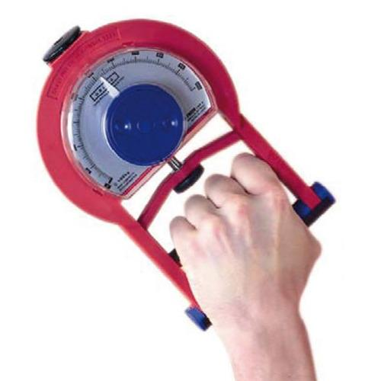
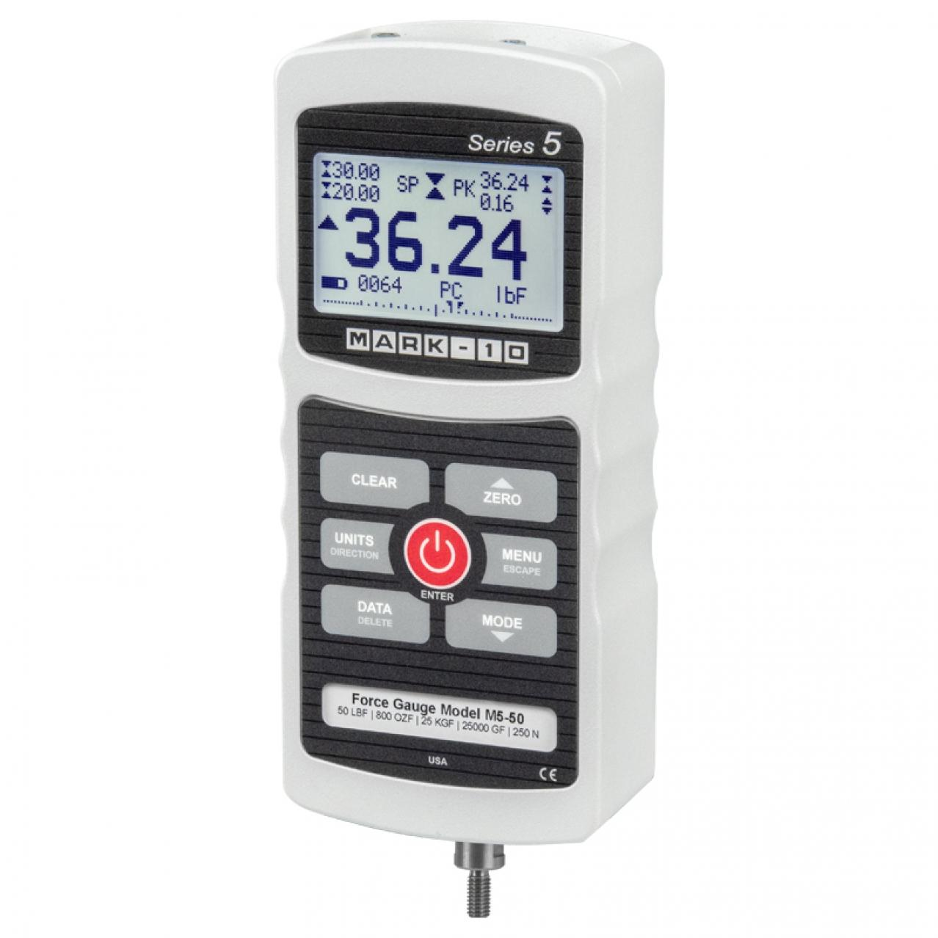
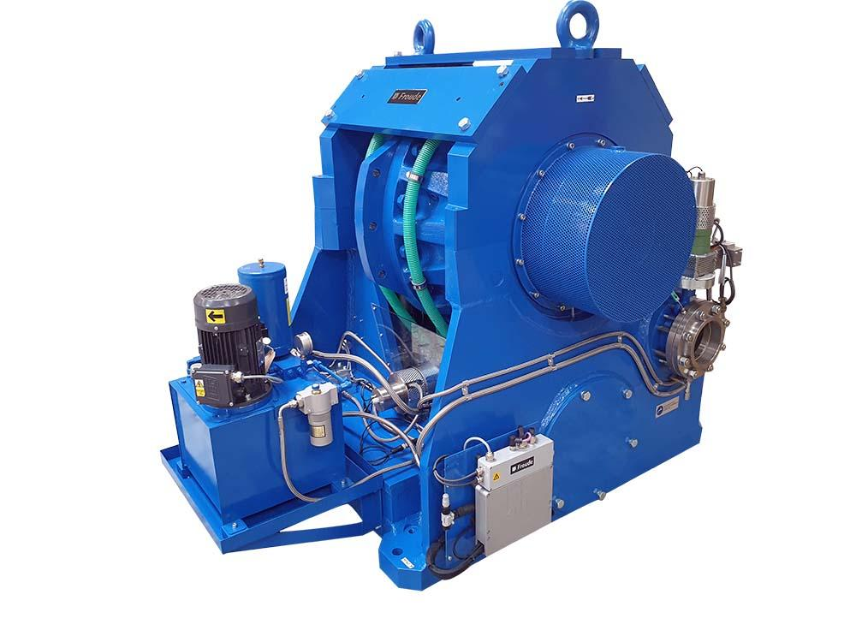
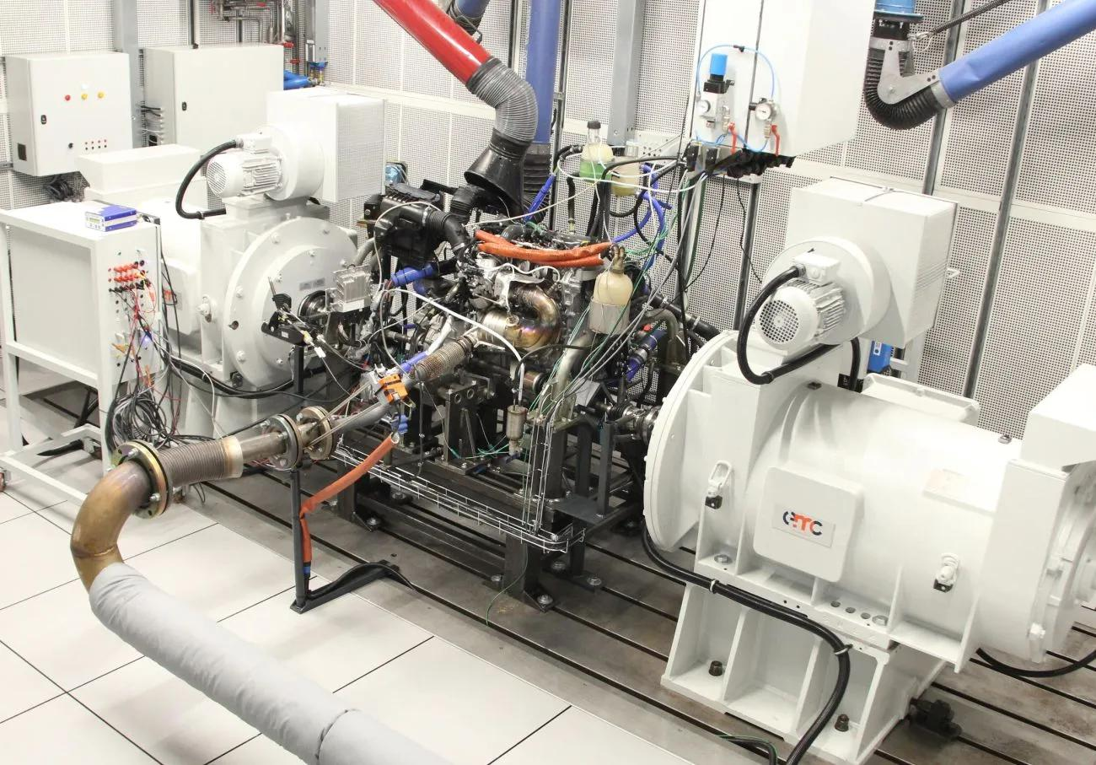
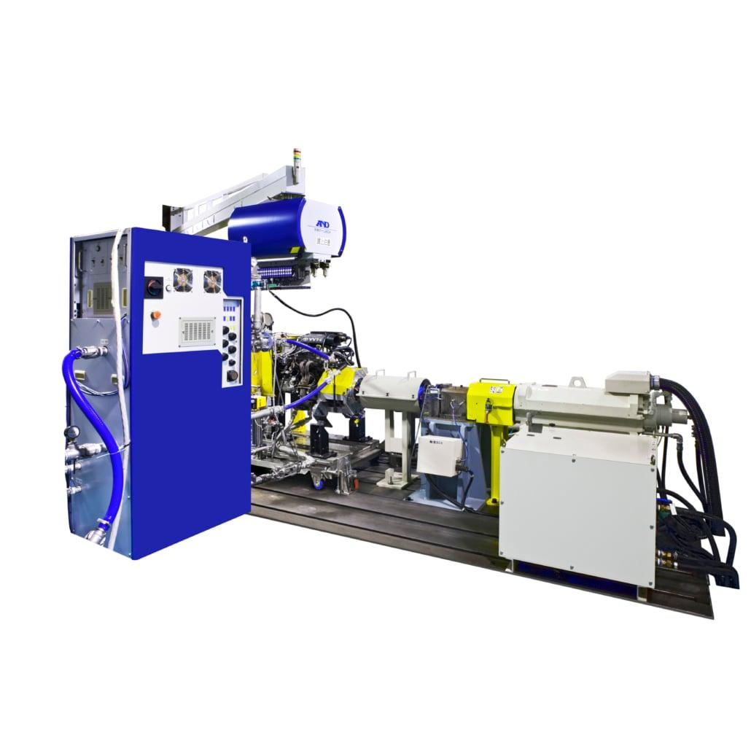
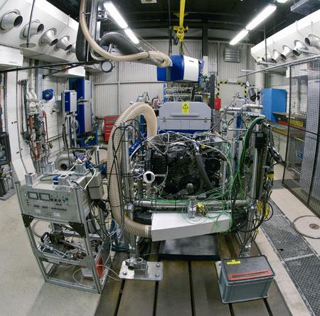
A Dynamometer is a force- and power-measuring instrument used to measure force, torque, or mechanical power produced by machines, motors, engines, muscles, or other mechanical systems. Depending on its design, a dynamometer can measure pulling force, pushing force, grip strength, torque, or engine power.
Dynamometers are widely used in engineering, automotive testing, industrial maintenance, biomechanics, sports science, healthcare, and research laboratories.

Definition
# Source: AI Source: Provided by: [Data Path: Persons Table -> ID Column: 1, Name_En Column: Motasem Essam] -> From: [ChatGPT] on [7/17/2026]
A Dynamometer is an instrument used to measure force, torque, or mechanical power generated by a machine, motor, engine, or human muscle.

Purpose
# Source: AI Source: Provided by: [Data Path: Persons Table -> ID Column: 1, Name_En Column: Motasem Essam] -> From: [ChatGPT] on [7/17/2026]
A dynamometer is used to:
- Measure pulling force.
- Measure pushing force.
- Measure grip strength.
- Measure engine power.
- Measure torque.
- Test electric motors.
- Evaluate mechanical performance.
- Perform industrial calibration and research.

Principle of Operation
# Source: AI Source: Provided by: [Data Path: Persons Table -> ID Column: 1, Name_En Column: Motasem Essam] -> From: [ChatGPT] on [7/17/2026]
The operating principle depends on the type of dynamometer.
Mechanical Dynamometer
Uses springs or mechanical linkages to convert force into displacement.
Hydraulic Dynamometer
Measures force through hydraulic pressure generated by the applied load.
Electronic (Load Cell) Dynamometer
Uses strain gauges or load cells to convert force into an electrical signal.
Engine Dynamometer
Applies a controlled load to an engine or motor and calculates torque and power from measured speed and force.

Main Components
# Source: AI Source: Provided by: [Data Path: Persons Table -> ID Column: 1, Name_En Column: Motasem Essam] -> From: [ChatGPT] on [7/17/2026]
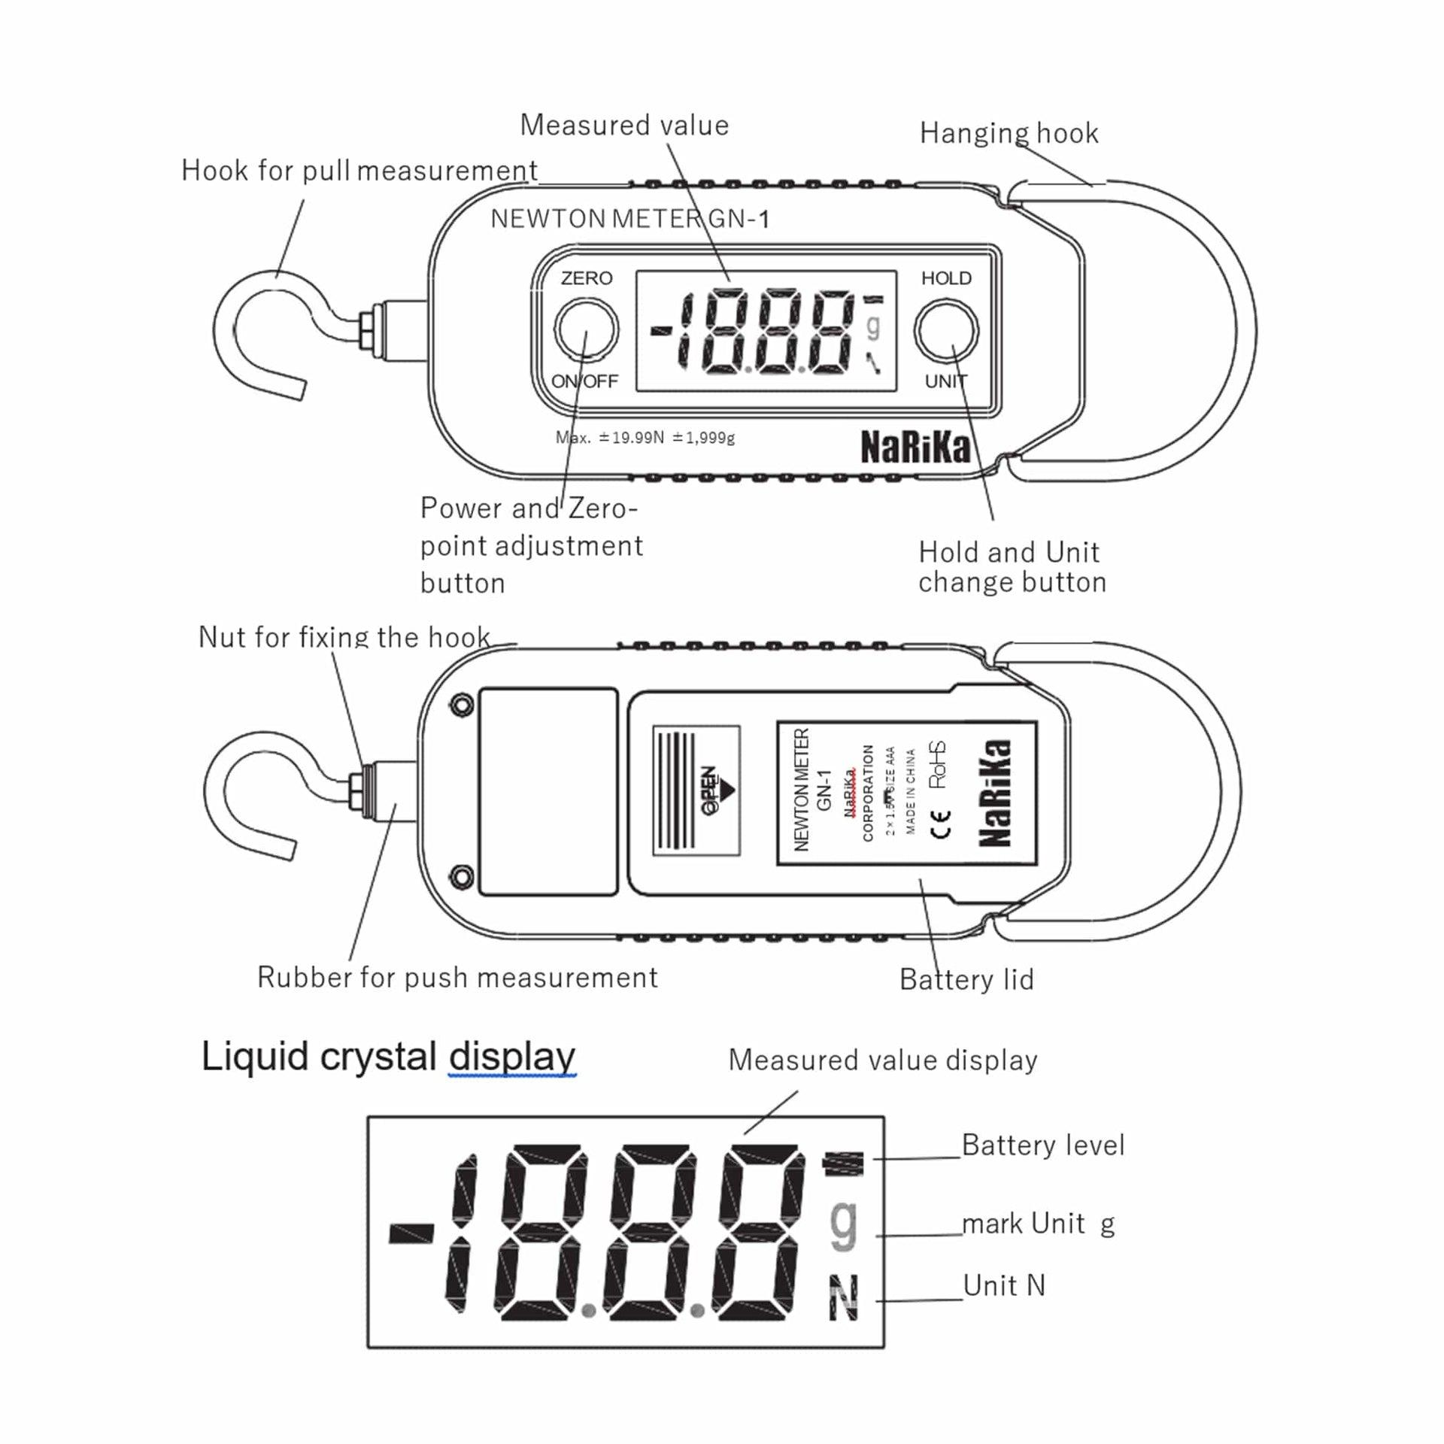
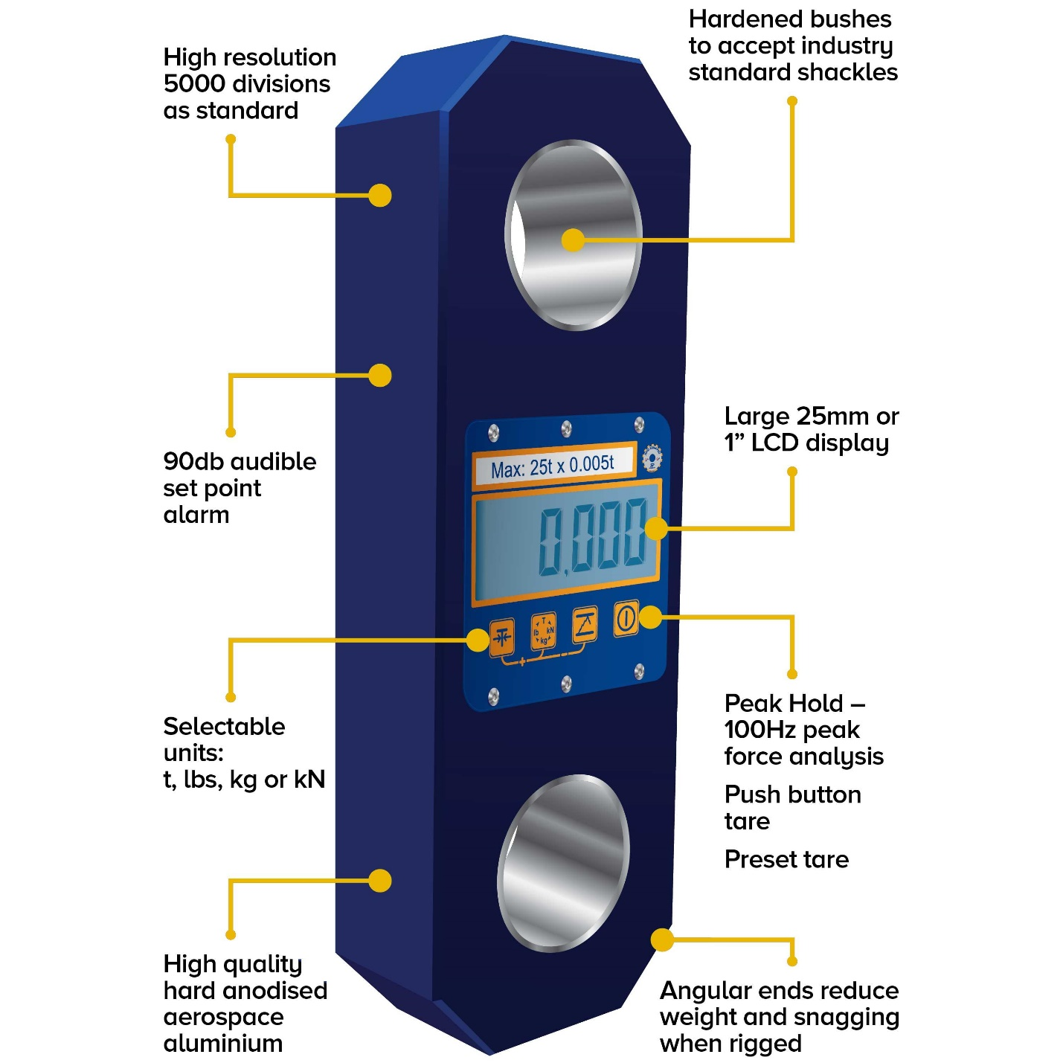
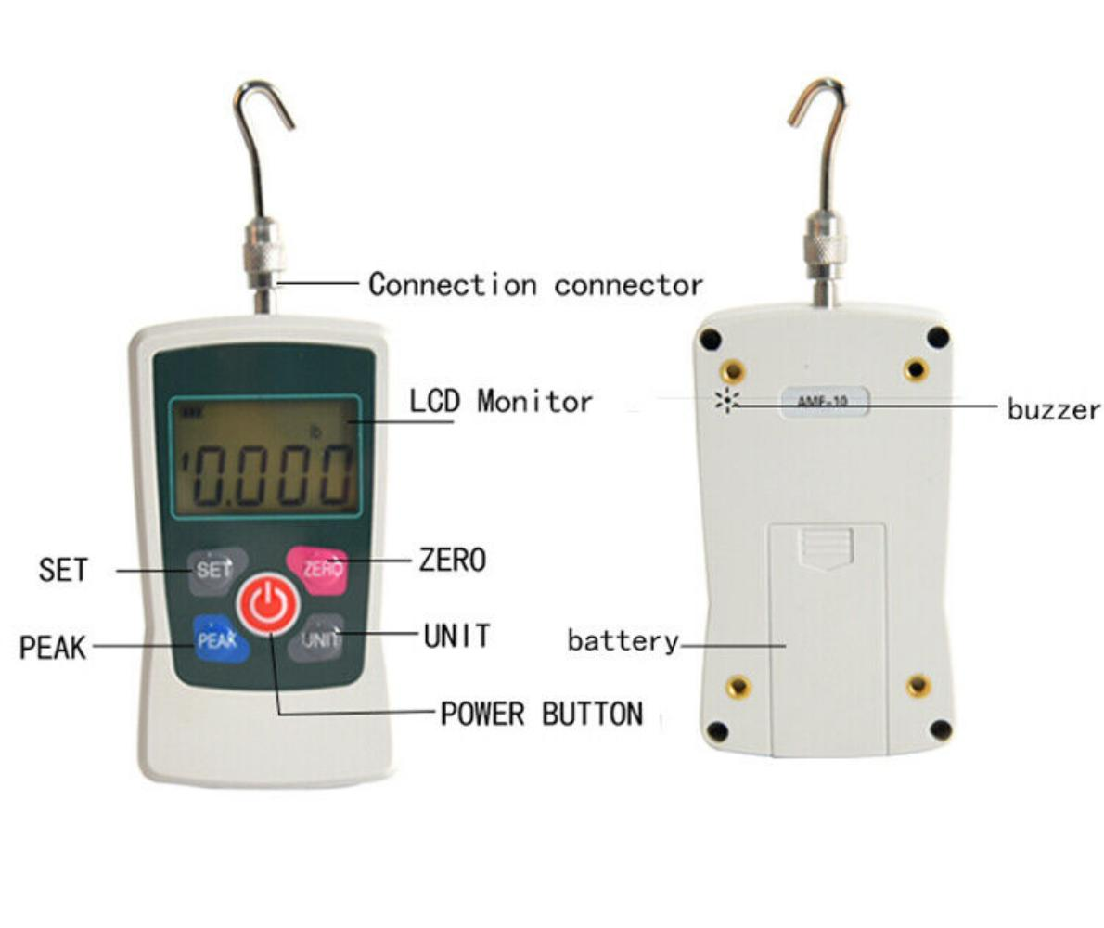
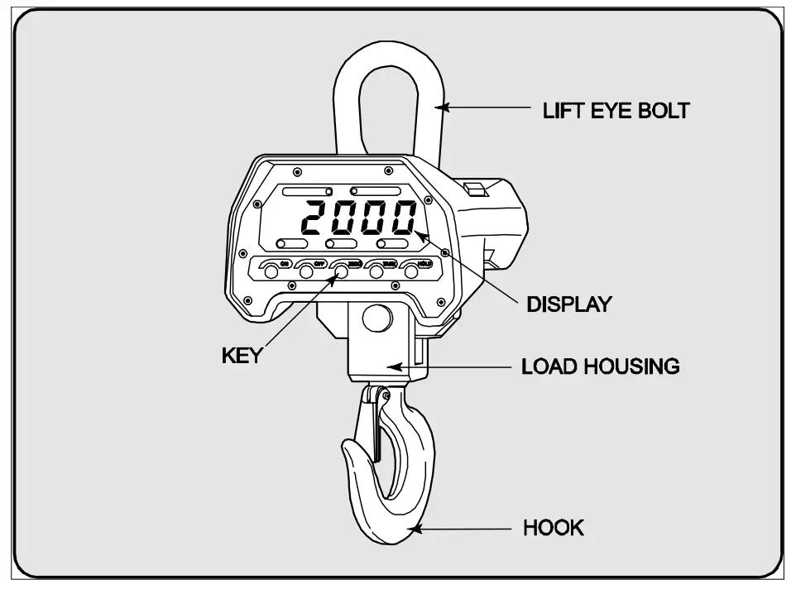
A typical dynamometer consists of:
- Force sensor (spring, hydraulic system, or load cell)
- Hook or mounting fixture
- Load application mechanism
- Display (analog or digital)
- Electronic processor (digital models)
- Power supply (digital models)

Types of Dynamometers

1. Mechanical Spring Dynamometer
# Source: AI Source: Provided by: [Data Path: Persons Table -> ID Column: 1, Name_En Column: Motasem Essam] -> From: [ChatGPT] on [7/17/2026]
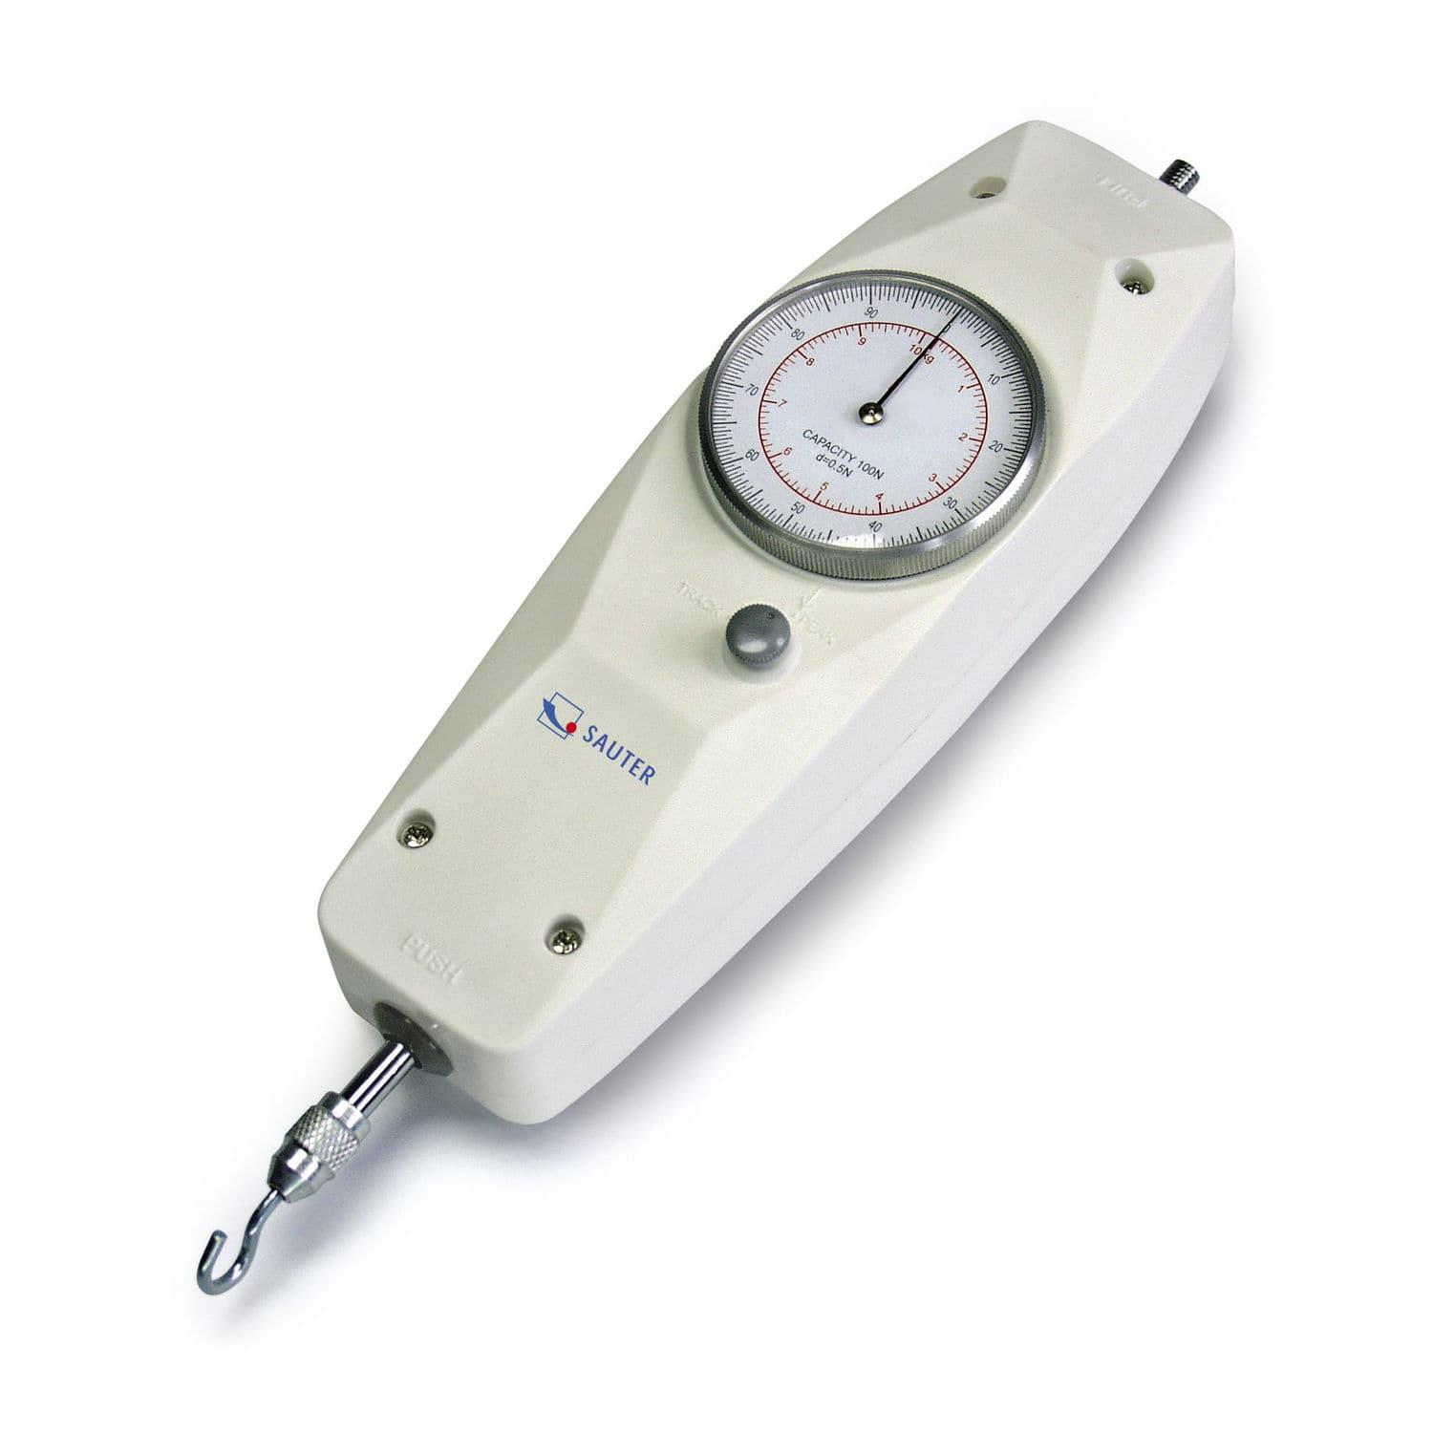
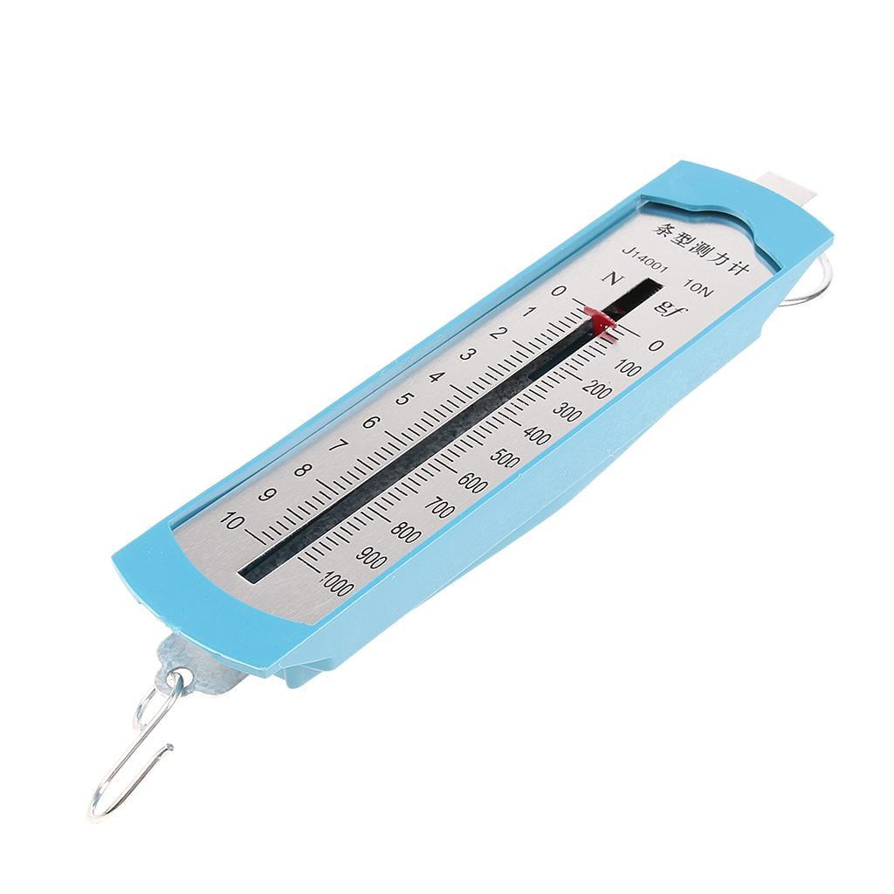
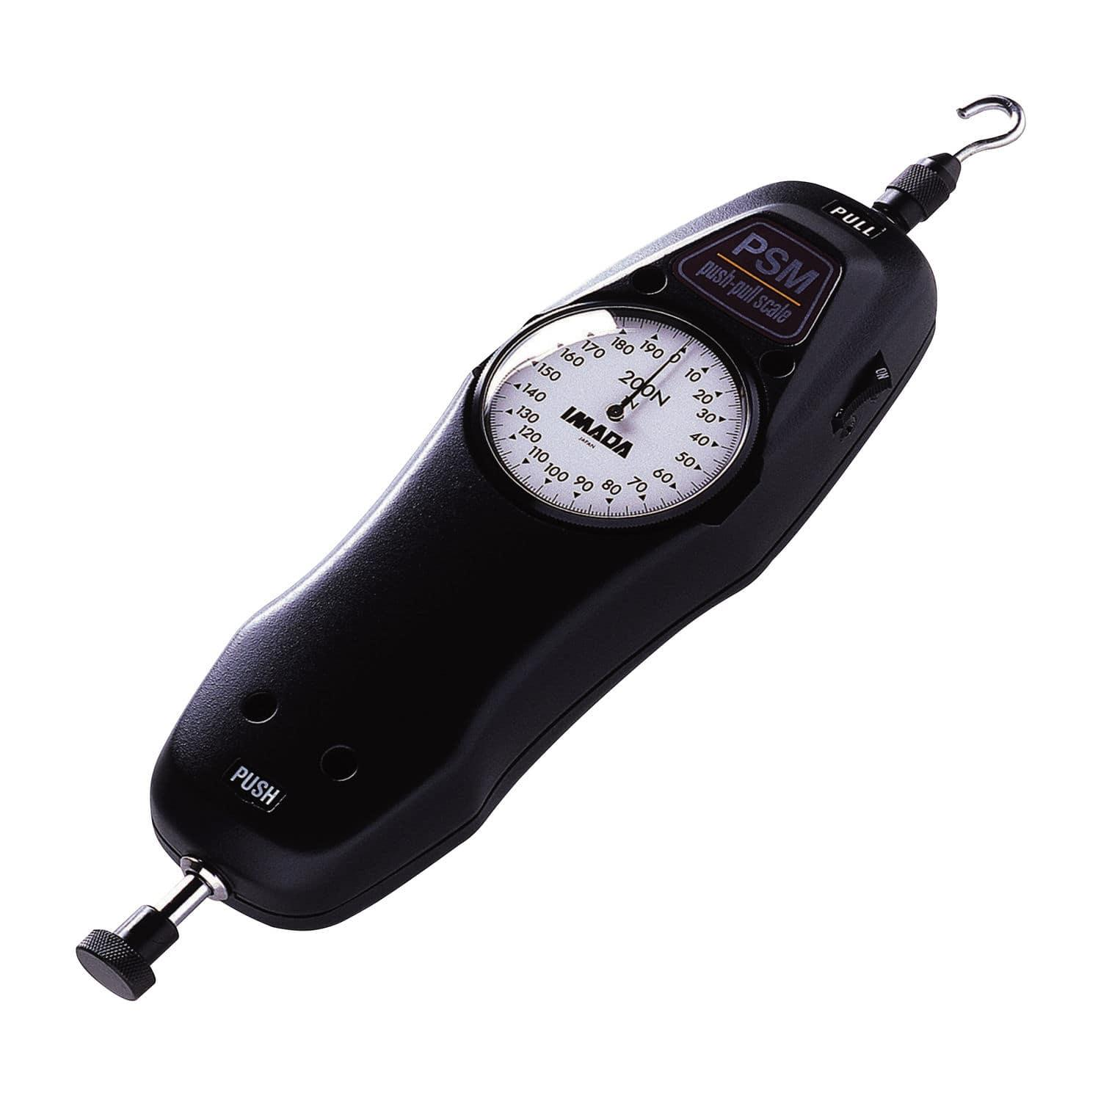
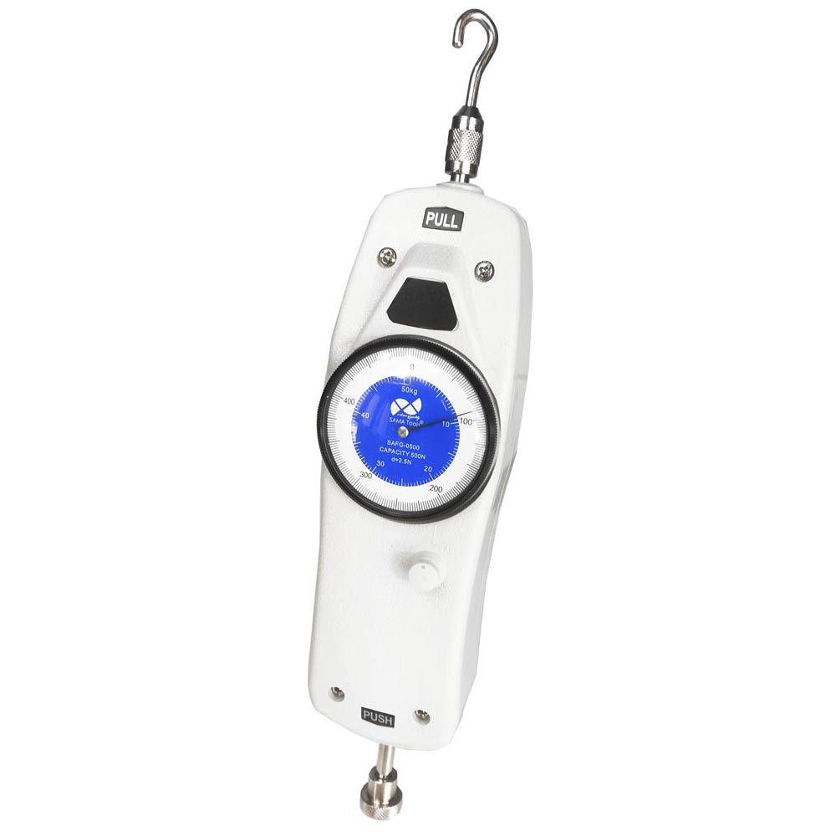
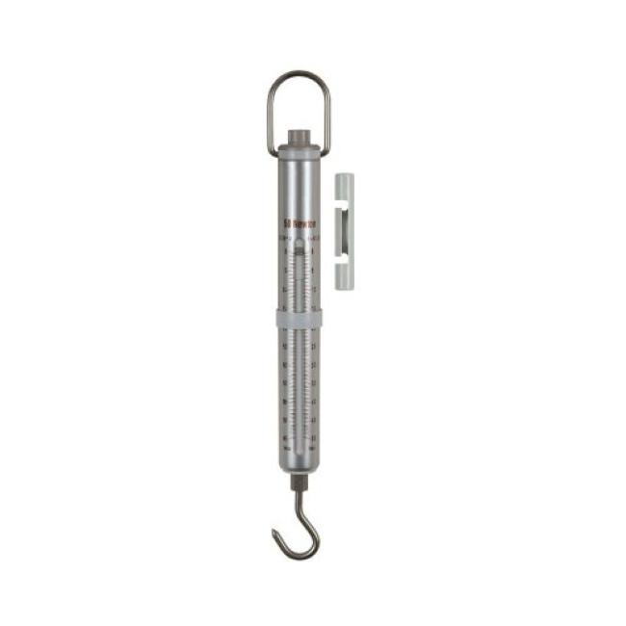
Description
Measures force using the extension or compression of a calibrated spring according to Hooke's Law.
Features
- Simple mechanical construction
- No electrical power required
- Analog scale
Applications
- Physics laboratories
- Educational demonstrations
- General force measurements

2. Hand Grip Dynamometer
# Source: AI Source: Provided by: [Data Path: Persons Table -> ID Column: 1, Name_En Column: Motasem Essam] -> From: [ChatGPT] on [7/17/2026]
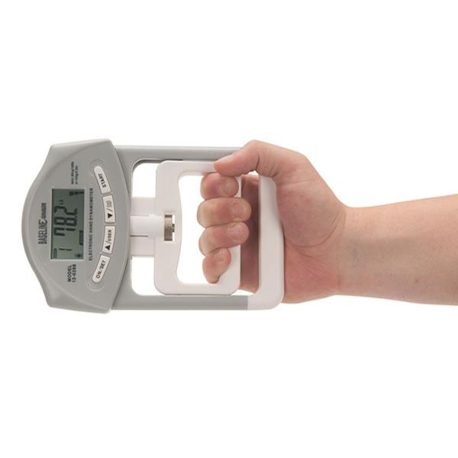
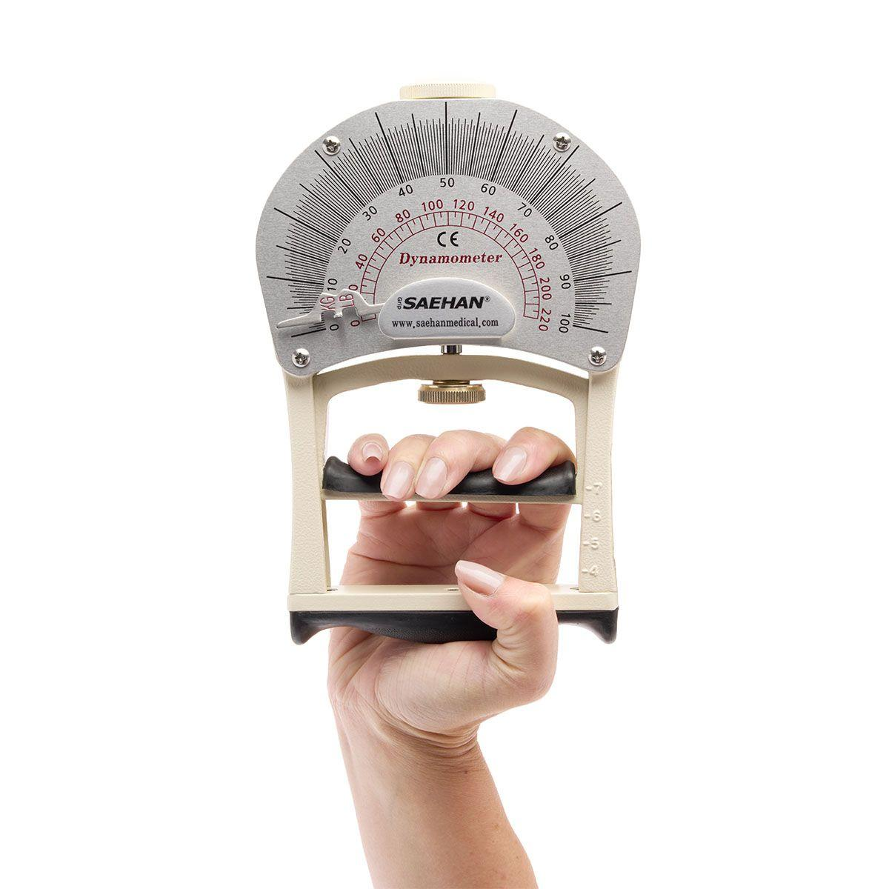
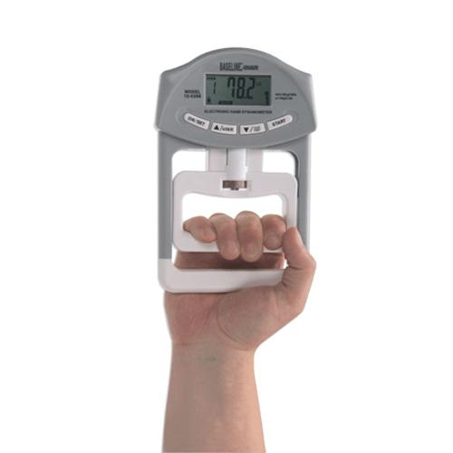
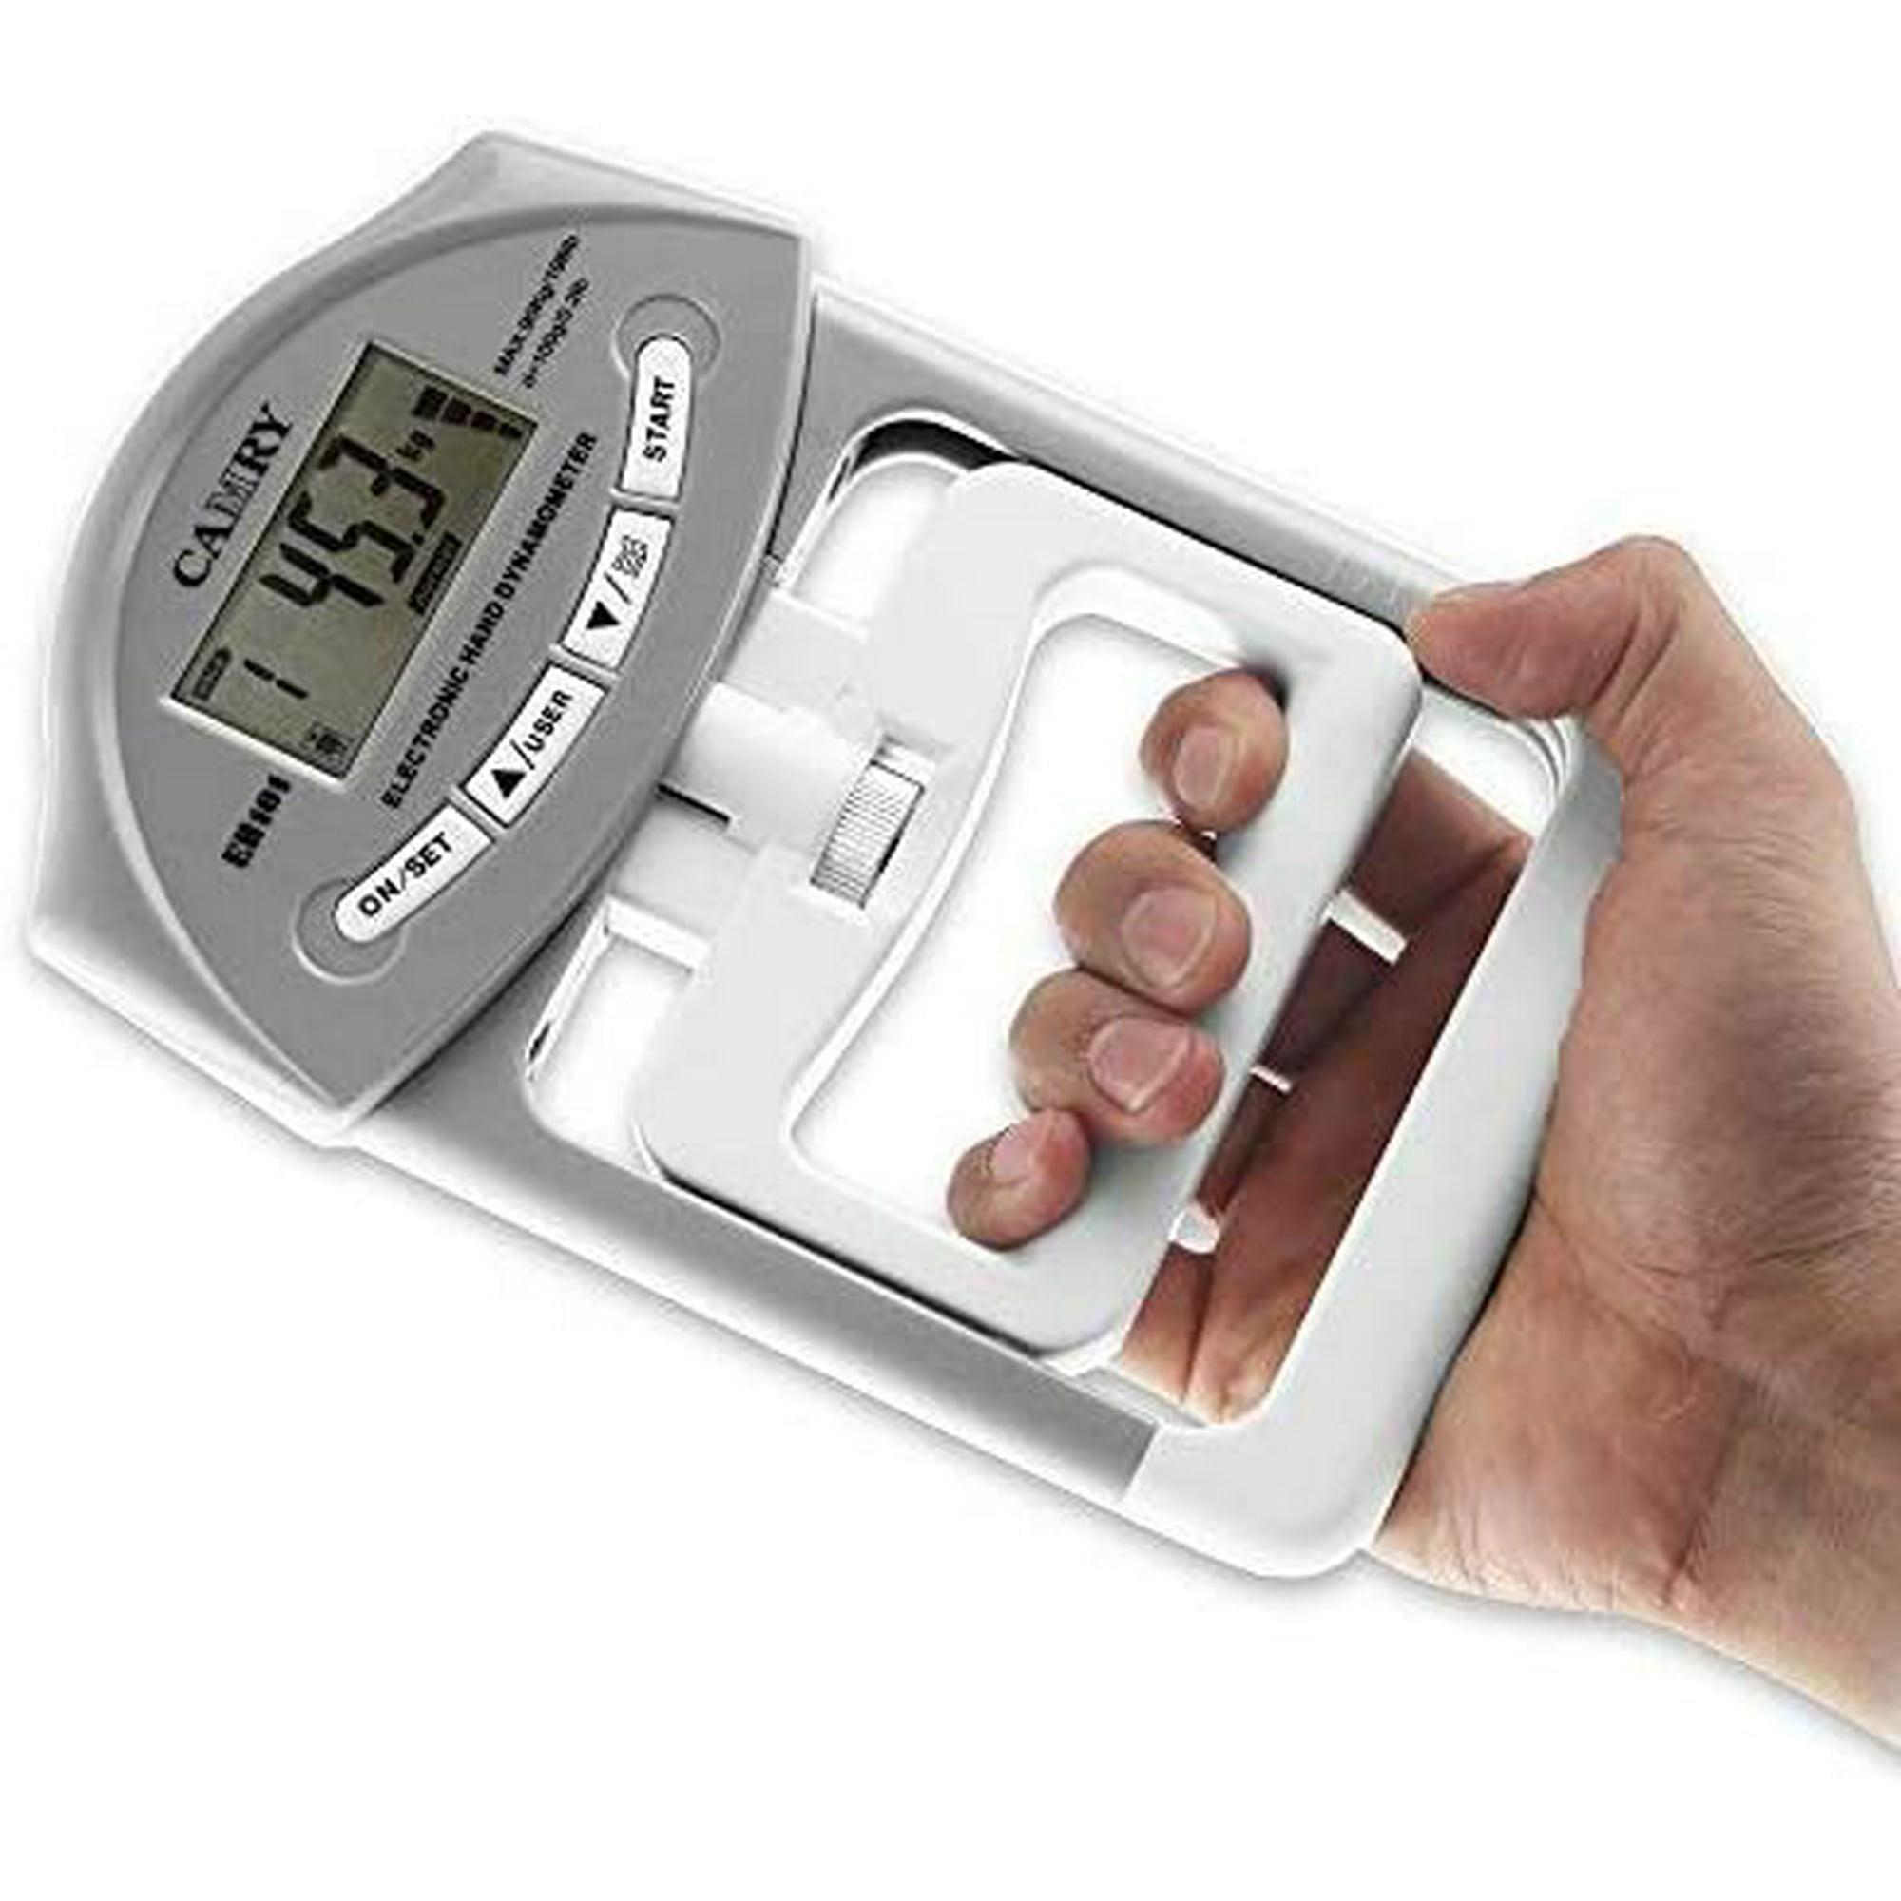
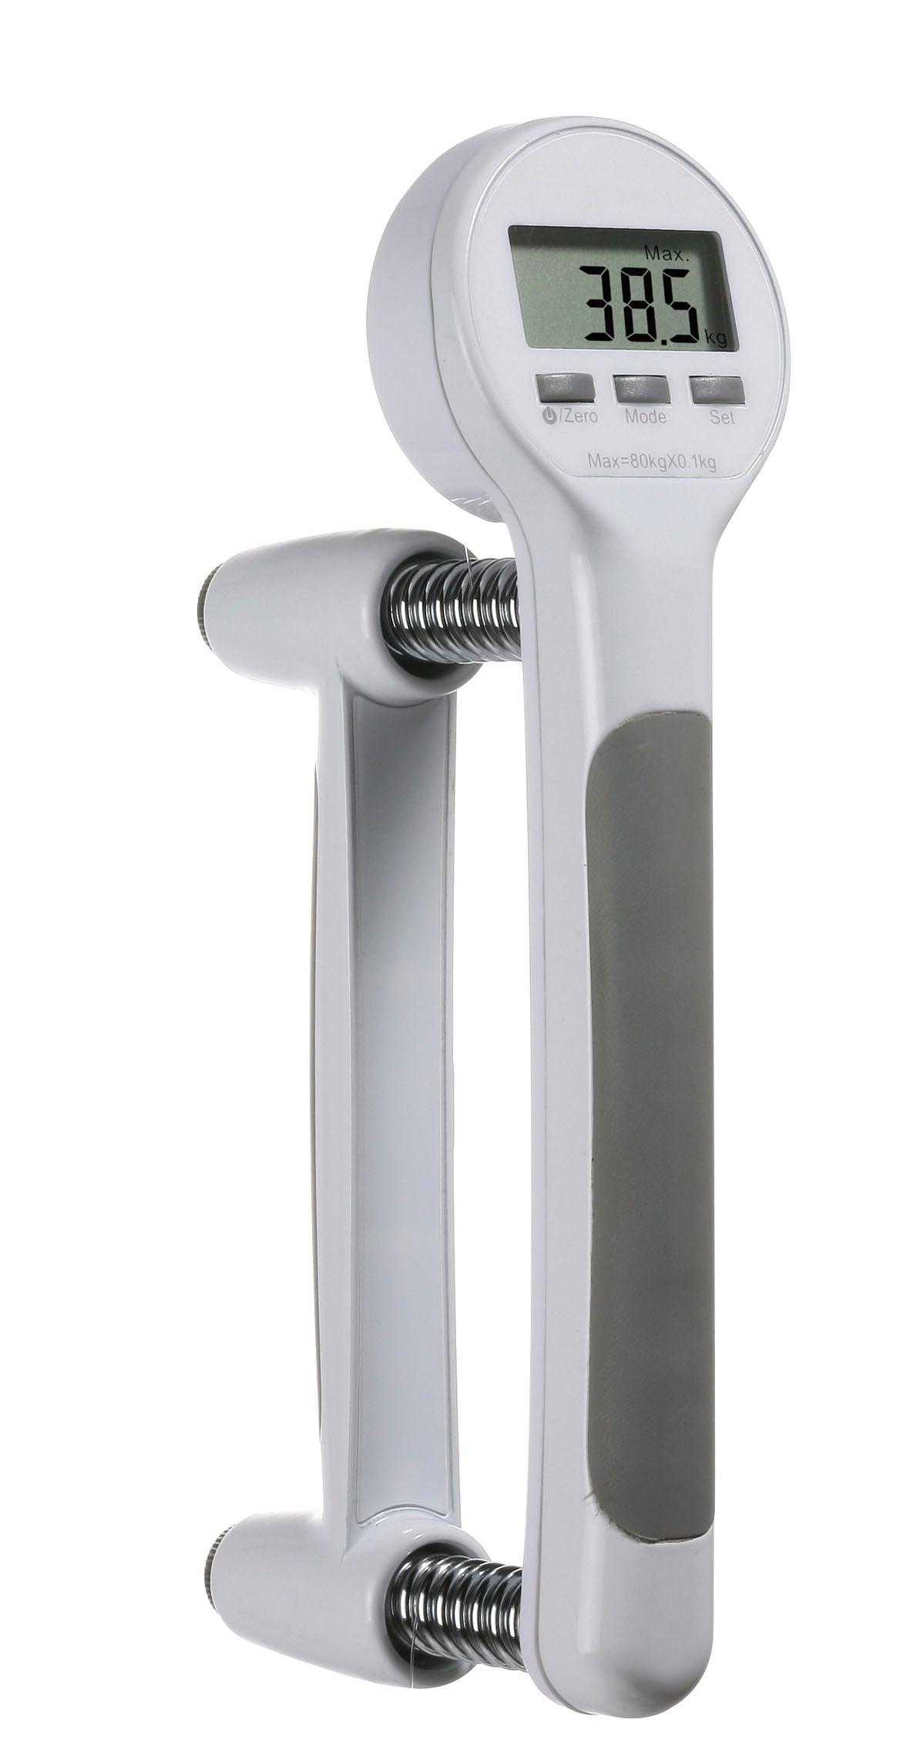
Description
Measures the maximum grip strength of a person's hand.
Features
- Portable
- Ergonomic handle
- Analog or digital display
Applications
- Physical therapy
- Rehabilitation
- Sports science
- Medical examinations

3. Digital Force Dynamometer
# Source: AI Source: Provided by: [Data Path: Persons Table -> ID Column: 1, Name_En Column: Motasem Essam] -> From: [ChatGPT] on [7/17/2026]
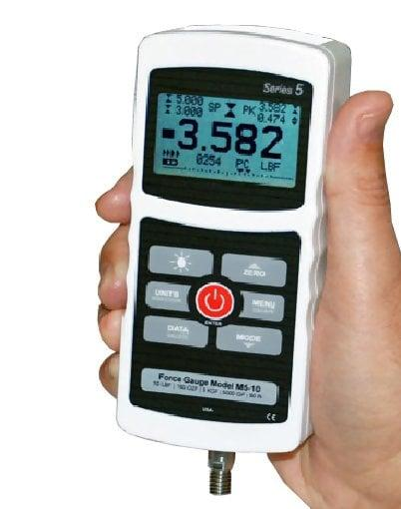
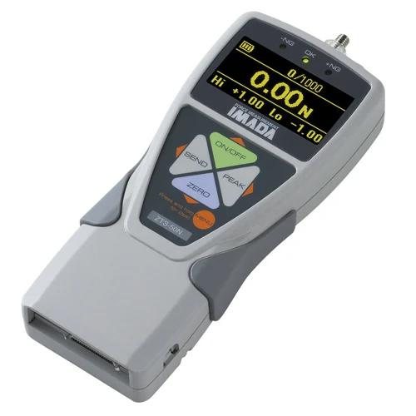
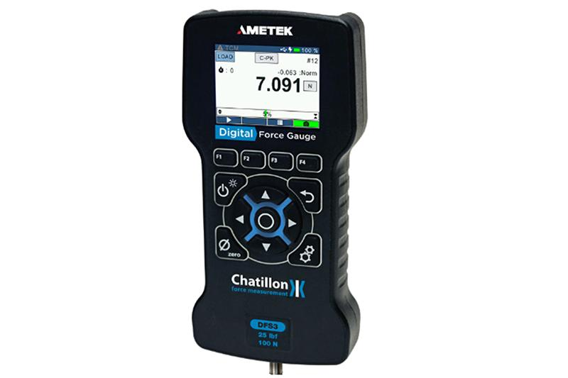
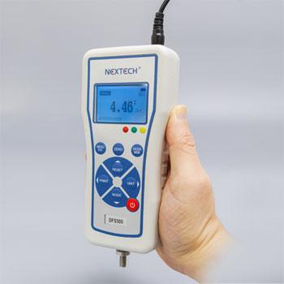
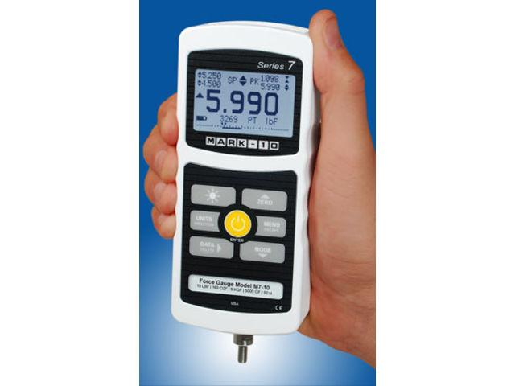
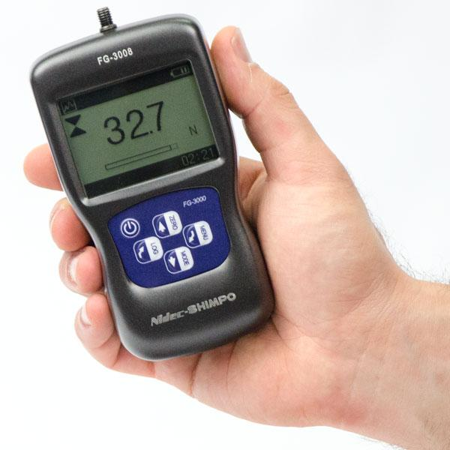
Description
Uses an electronic load cell to accurately measure tensile and compressive forces.
Features
- Digital display
- High precision
- Data recording capability (some models)
Applications
- Industrial testing
- Quality control
- Laboratories
- Research

4. Hydraulic Dynamometer
# Source: AI Source: Provided by: [Data Path: Persons Table -> ID Column: 1, Name_En Column: Motasem Essam] -> From: [ChatGPT] on [7/17/2026]

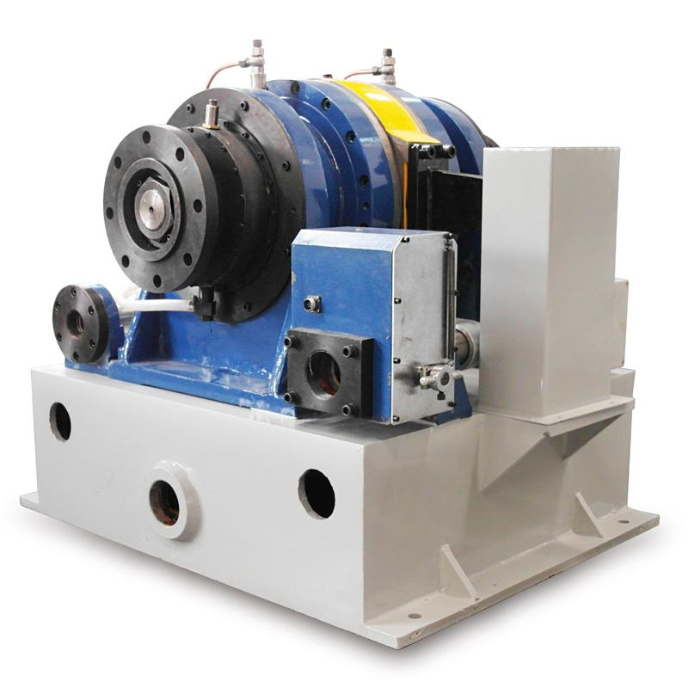
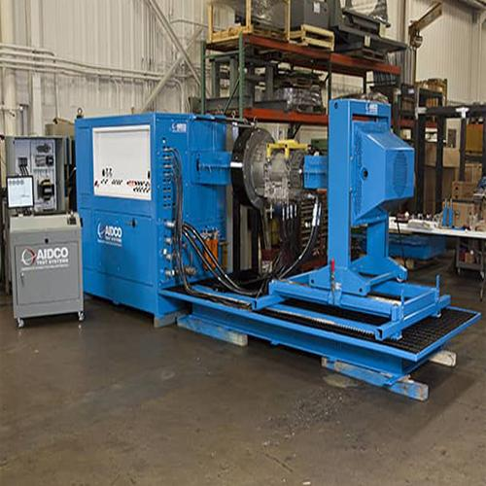
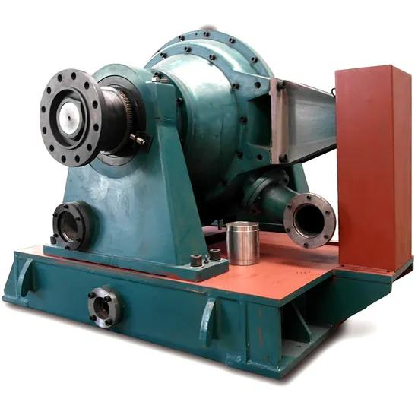
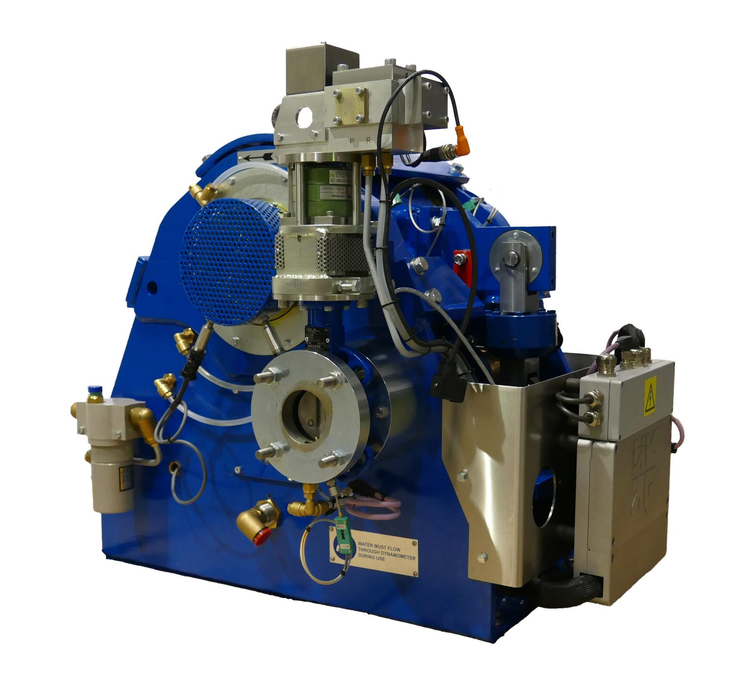
Description
Measures force by converting the applied load into hydraulic pressure.
Features
- Suitable for very large forces
- Rugged construction
- High load capacity
Applications
- Heavy industry
- Material testing
- Structural testing
- Engineering

5. Engine Dynamometer (Engine Dyno)
# Source: AI Source: Provided by: [Data Path: Persons Table -> ID Column: 1, Name_En Column: Motasem Essam] -> From: [ChatGPT] on [7/17/2026]
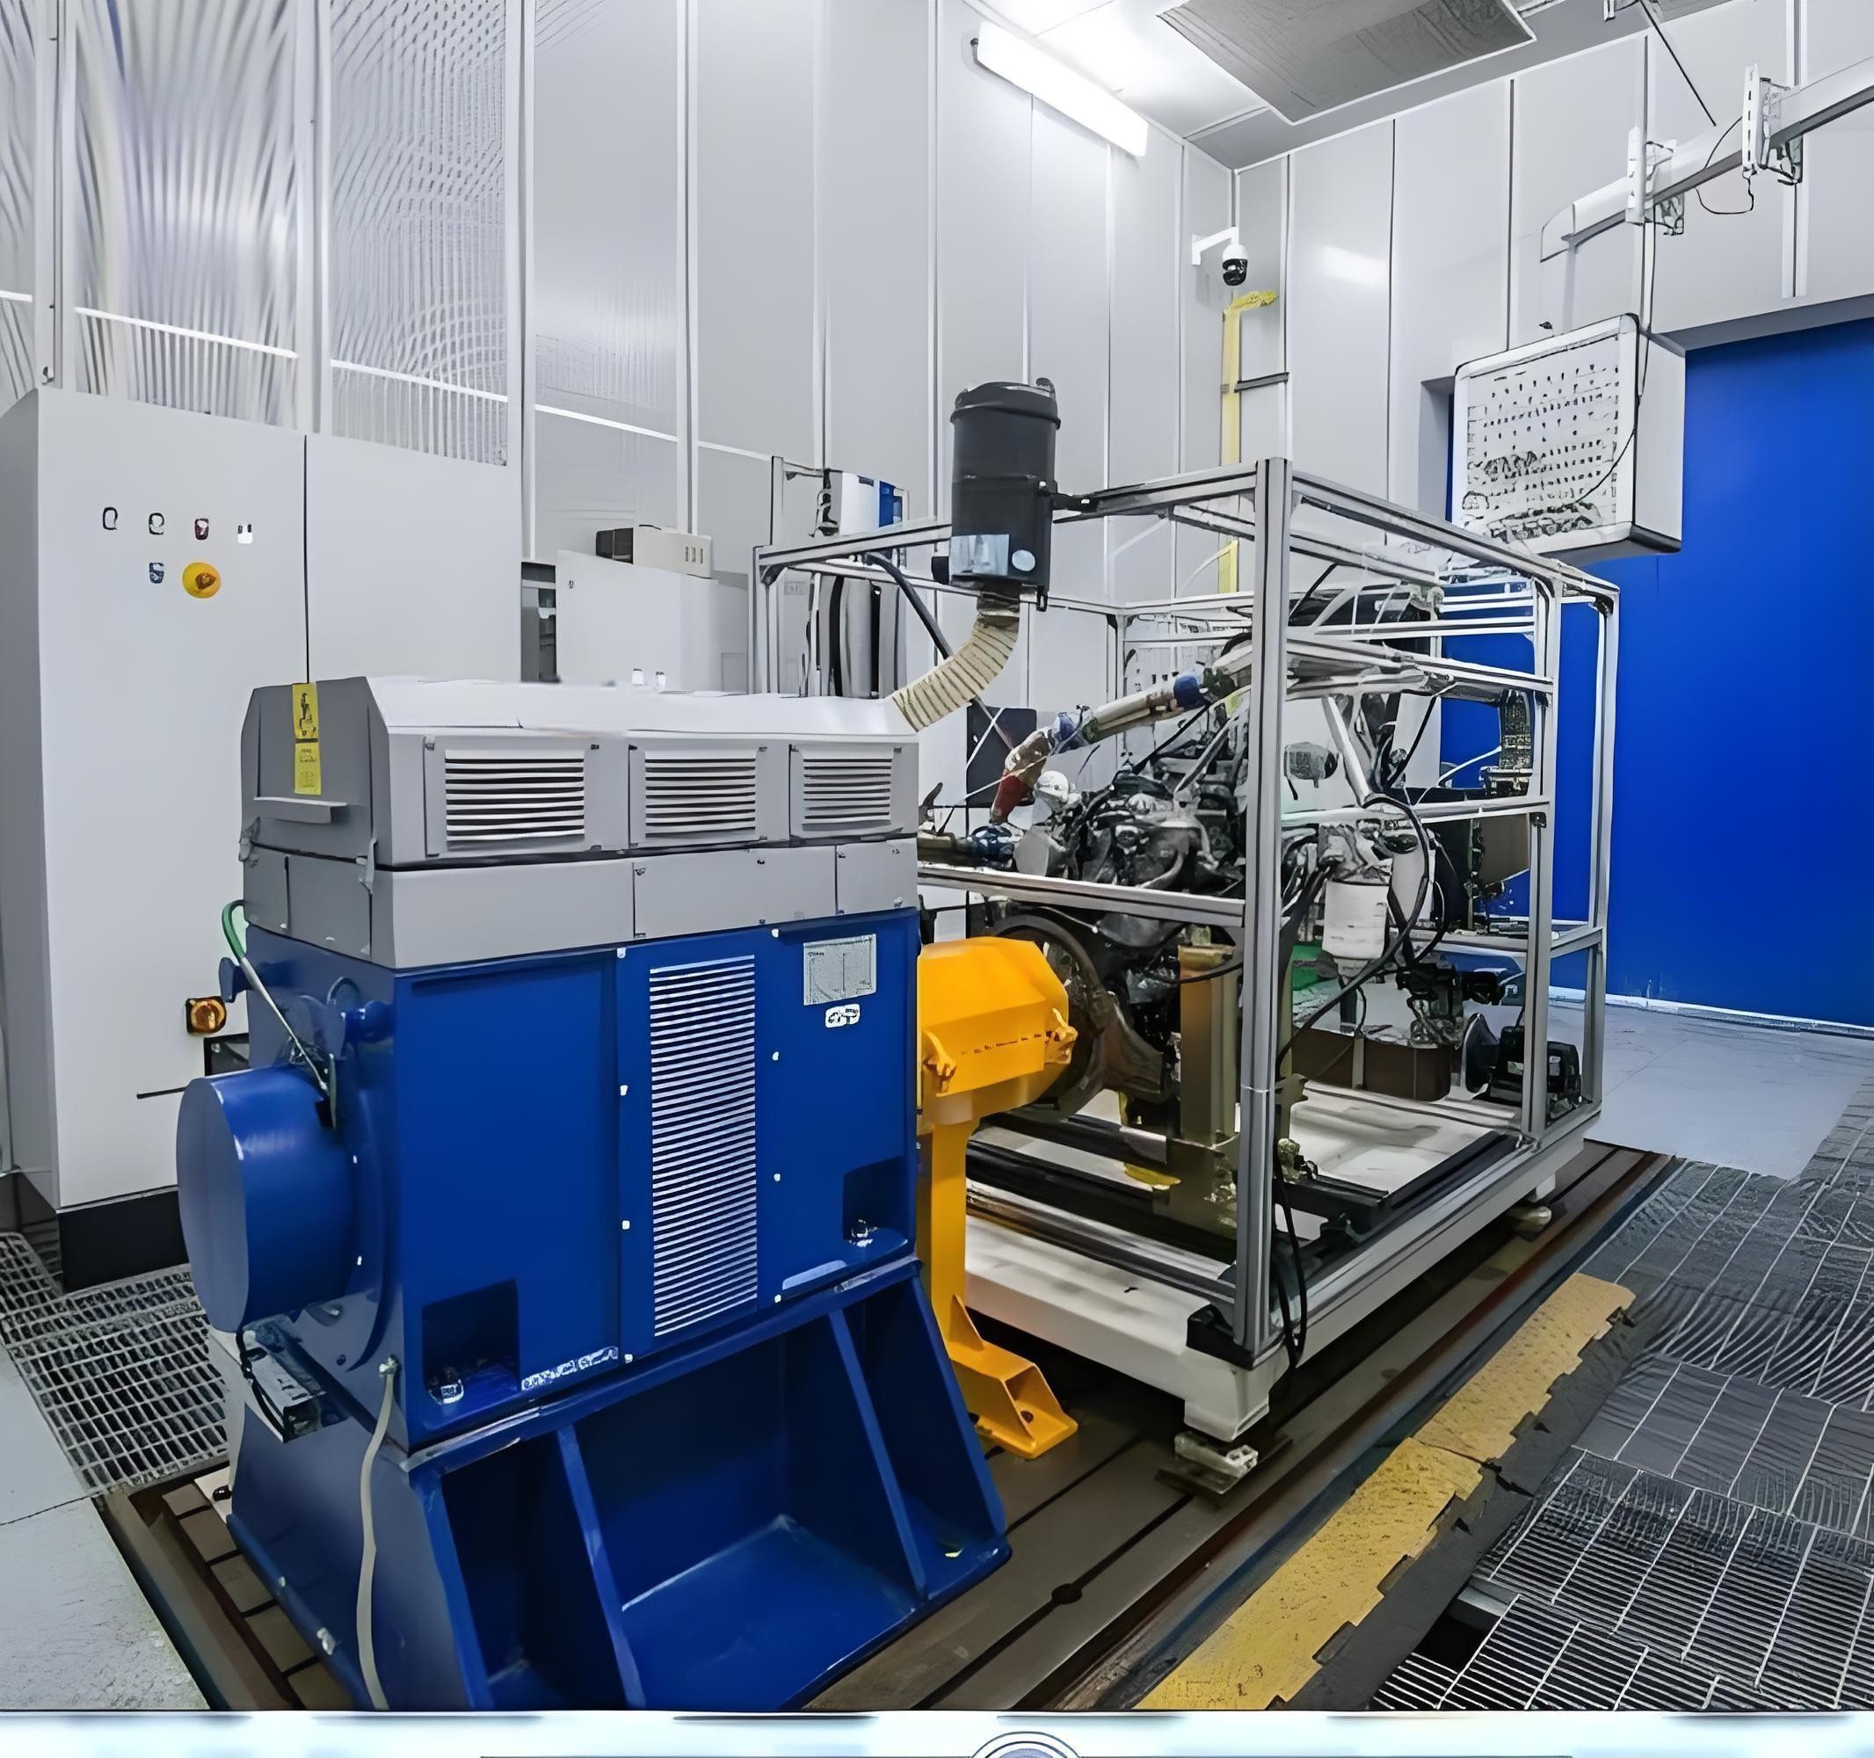

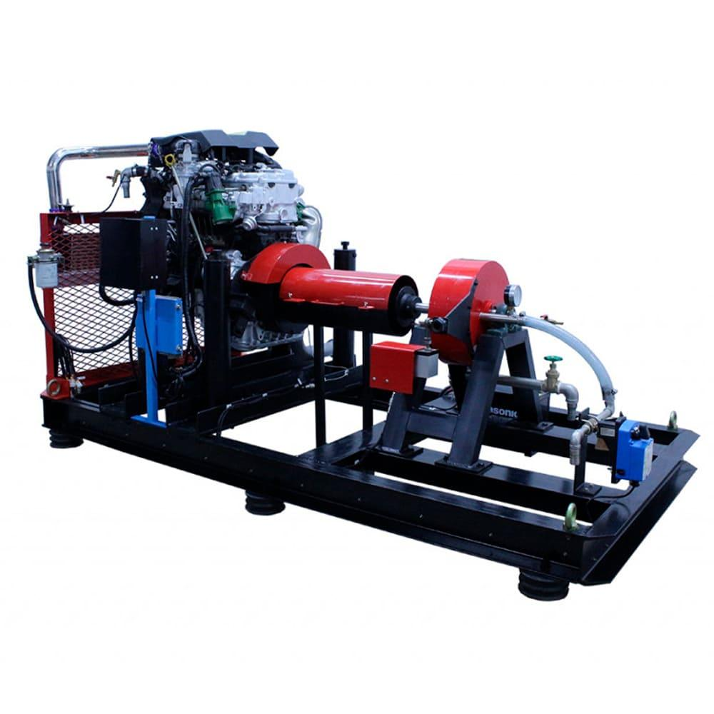
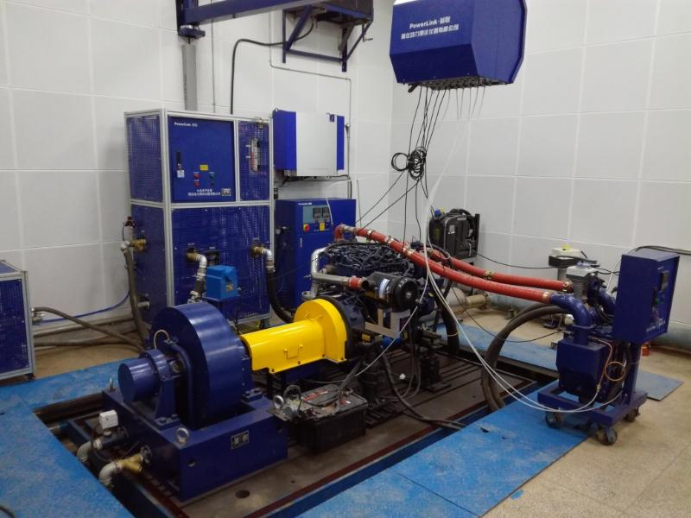
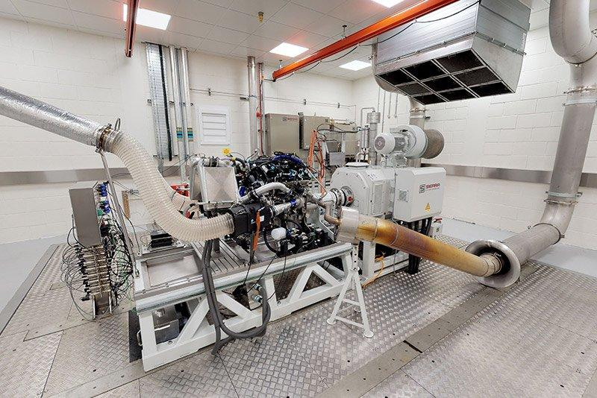
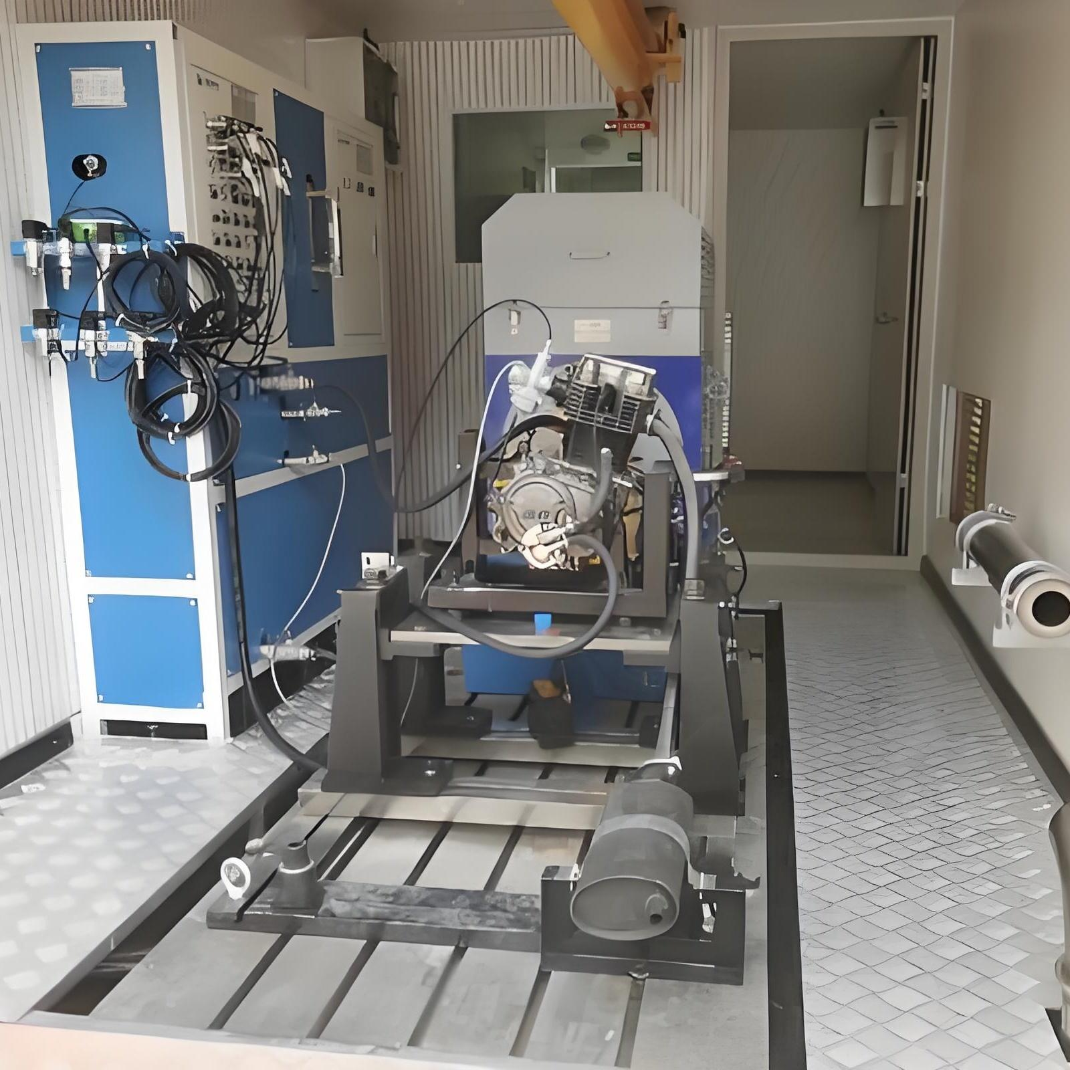
Description
Measures an engine's torque, rotational speed, and power output while the engine operates under controlled conditions.
Features
- Measures horsepower
- Measures torque
- Performance analysis
- Engine tuning
Applications
- Automotive engineering
- Engine development
- Racing
- Research laboratories

6. Chassis Dynamometer
# Source: AI Source: Provided by: [Data Path: Persons Table -> ID Column: 1, Name_En Column: Motasem Essam] -> From: [ChatGPT] on [7/17/2026]
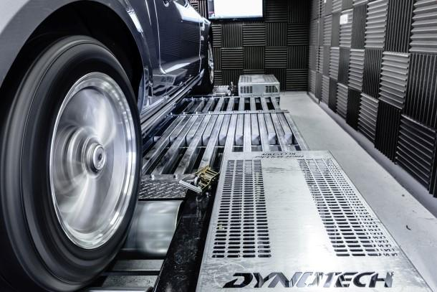
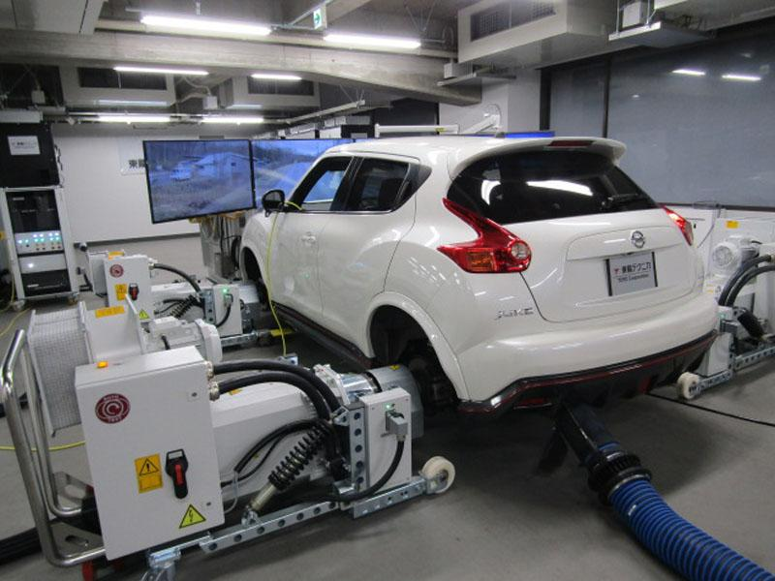
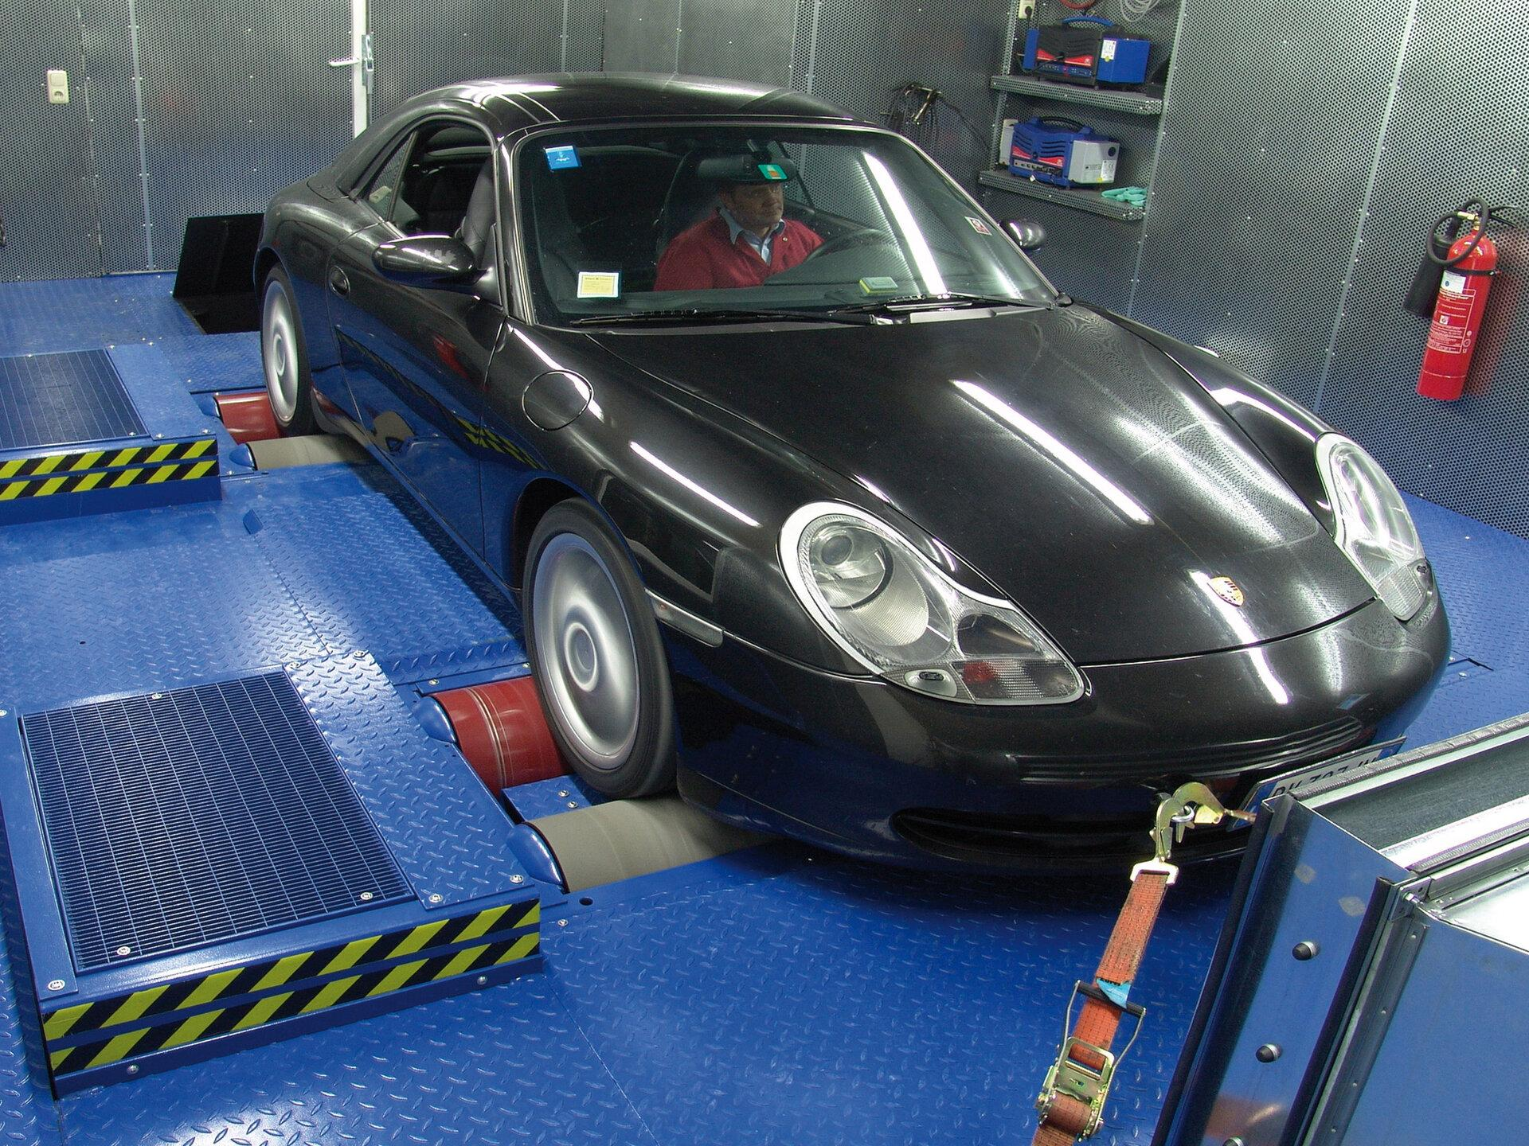
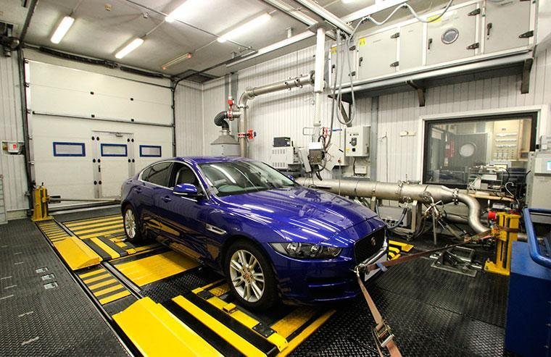
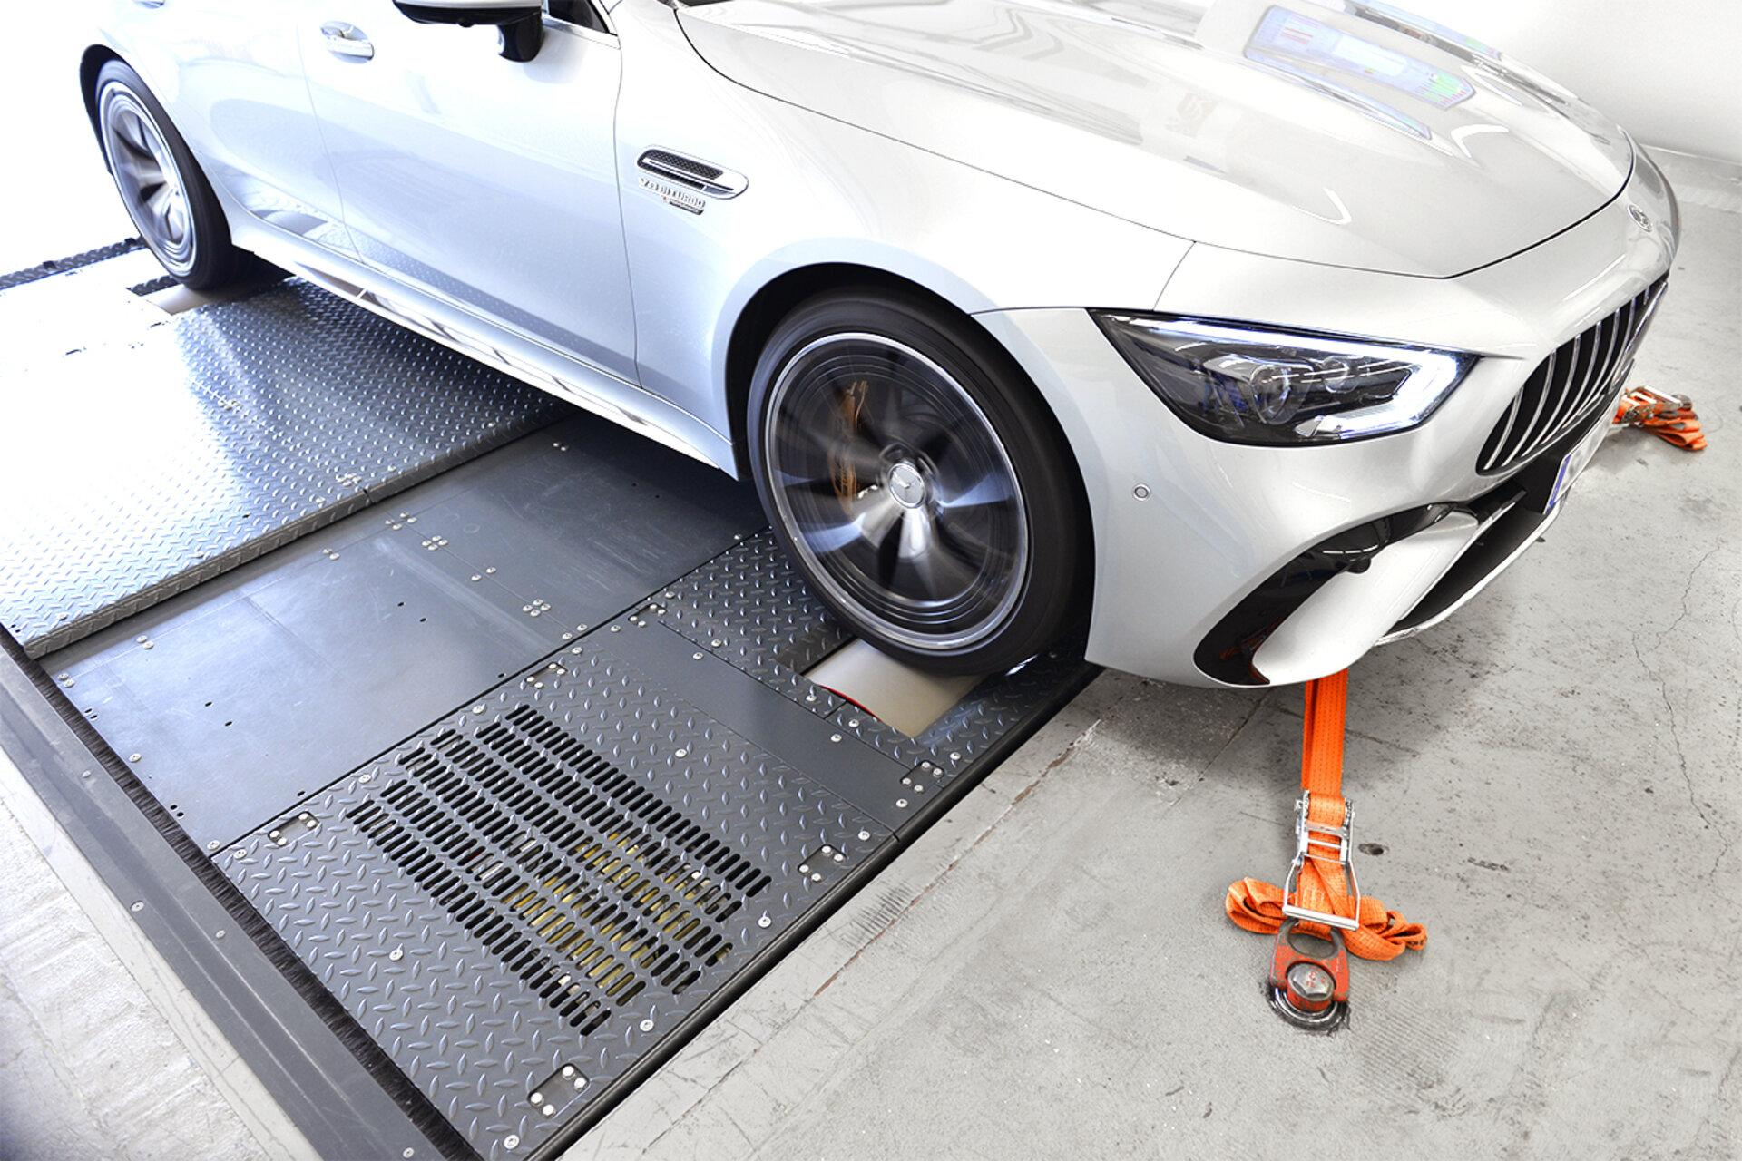
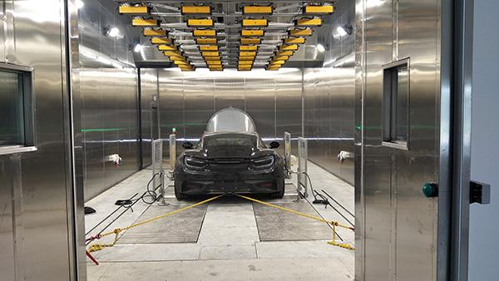
Description
Measures the performance of a complete vehicle by placing its driven wheels on powered rollers.
Features
- Whole-vehicle testing
- No engine removal required
- Simulates real driving conditions
Applications
- Vehicle performance testing
- Emissions testing
- Automotive tuning
- Research

7. Eddy Current Dynamometer
# Source: AI Source: Provided by: [Data Path: Persons Table -> ID Column: 1, Name_En Column: Motasem Essam] -> From: [ChatGPT] on [7/17/2026]
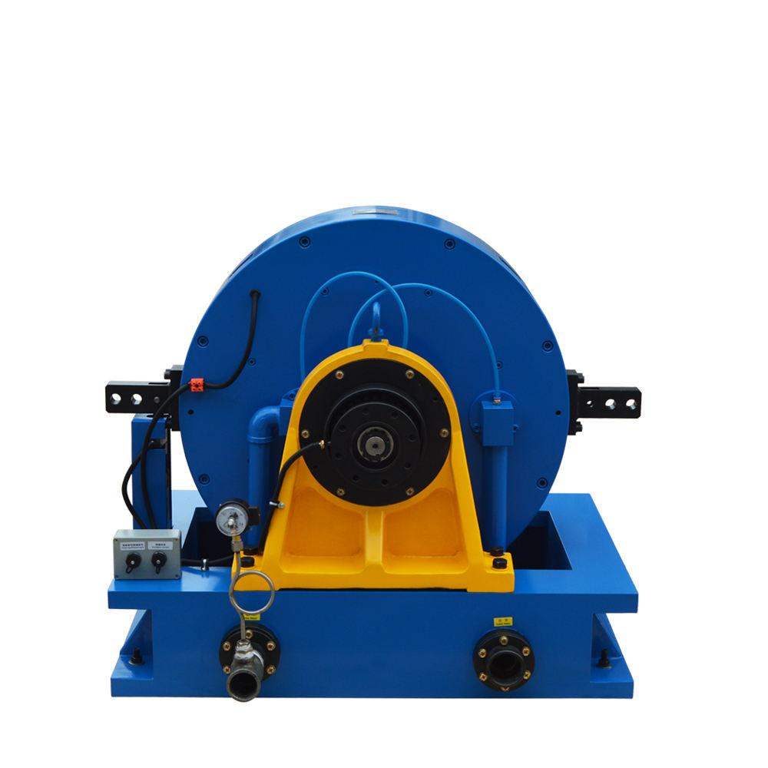
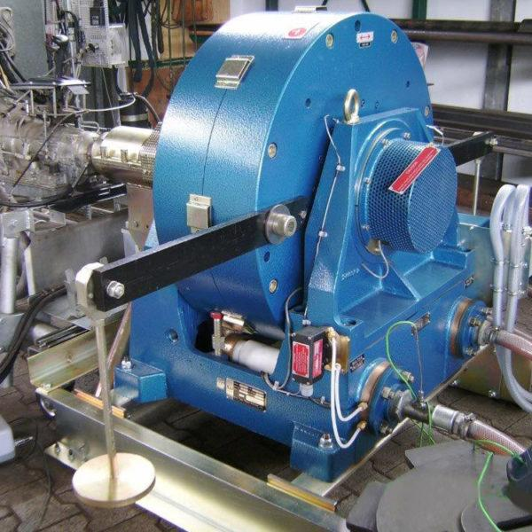
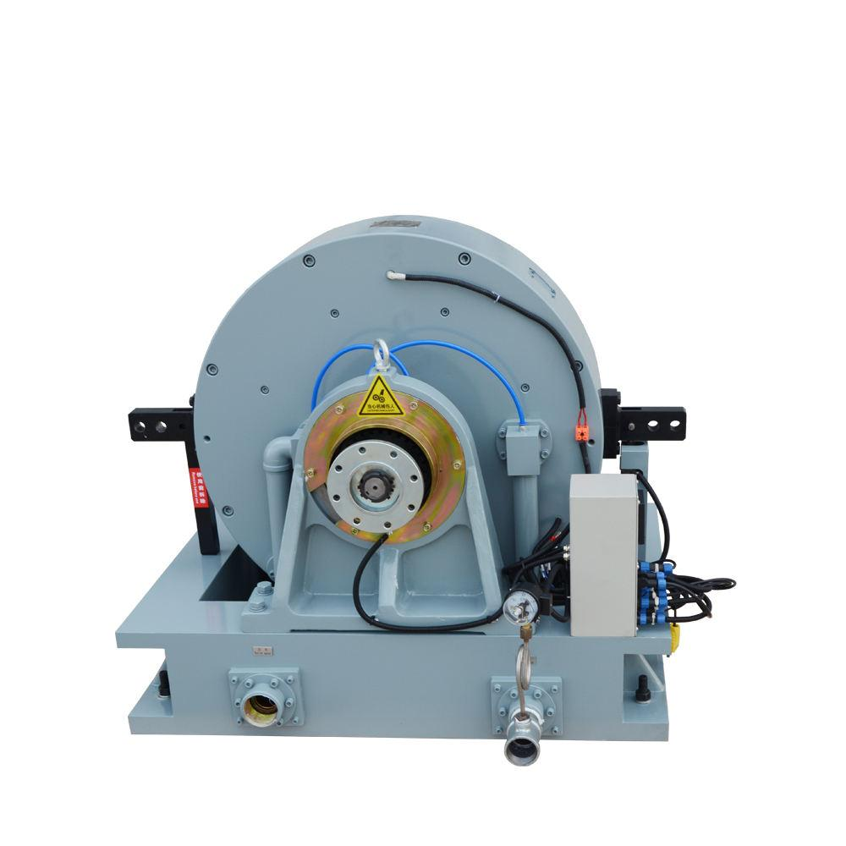
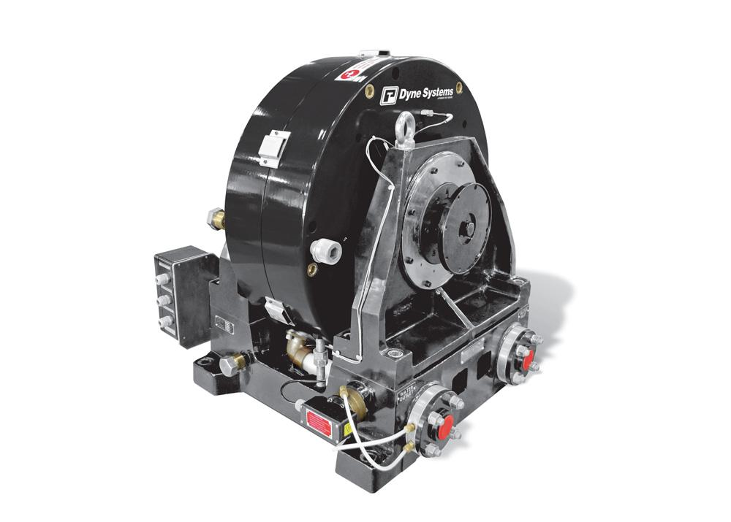
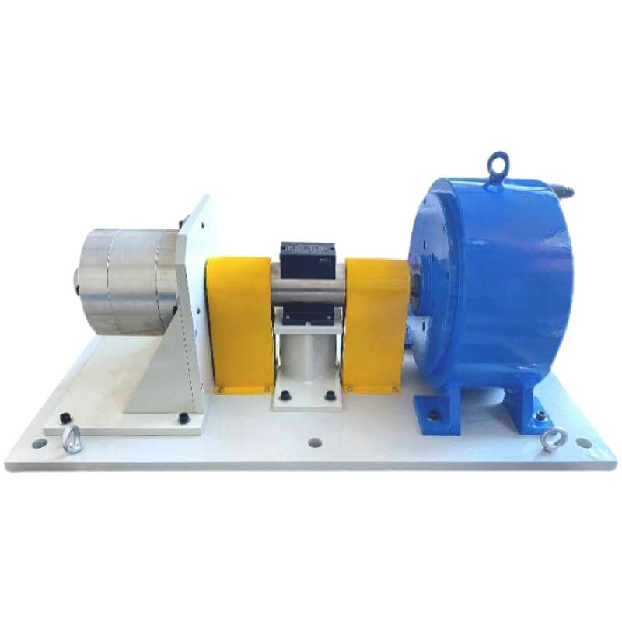
Description
Uses electromagnetic induction to create a controllable load for measuring torque and power.
Features
- Smooth load control
- High accuracy
- Fast response
Applications
- Engine testing
- Electric motor testing
- Industrial research

8. Water Brake Dynamometer
# Source: AI Source: Provided by: [Data Path: Persons Table -> ID Column: 1, Name_En Column: Motasem Essam] -> From: [ChatGPT] on [7/17/2026]
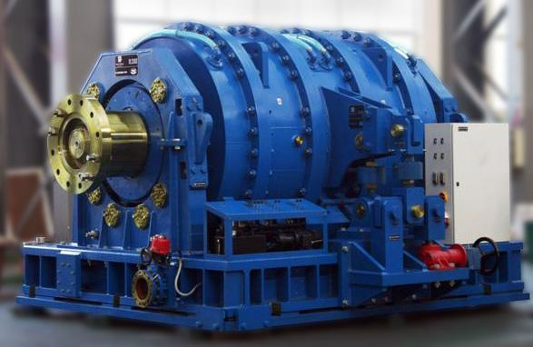
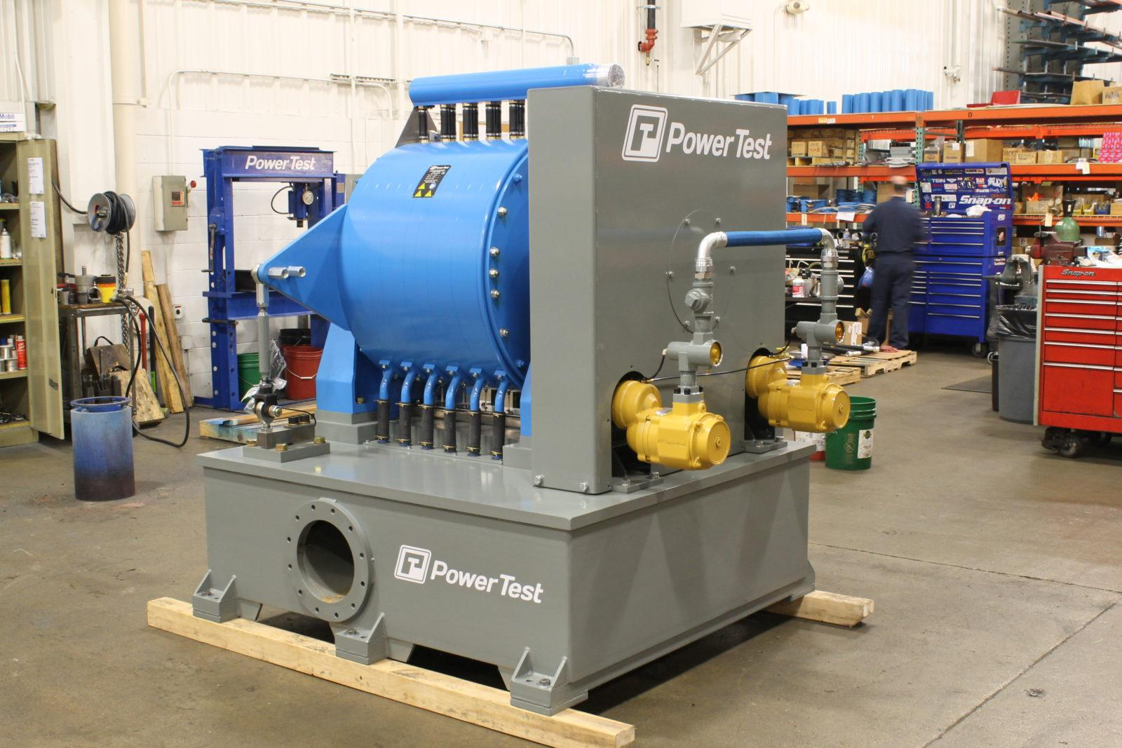
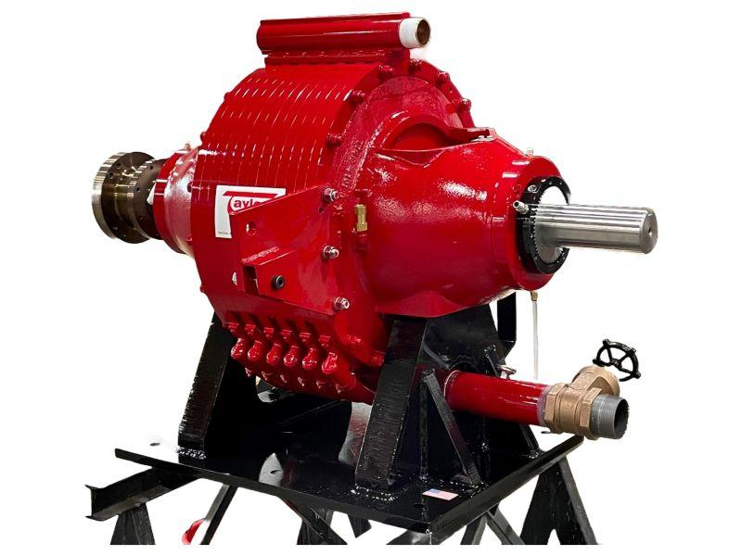
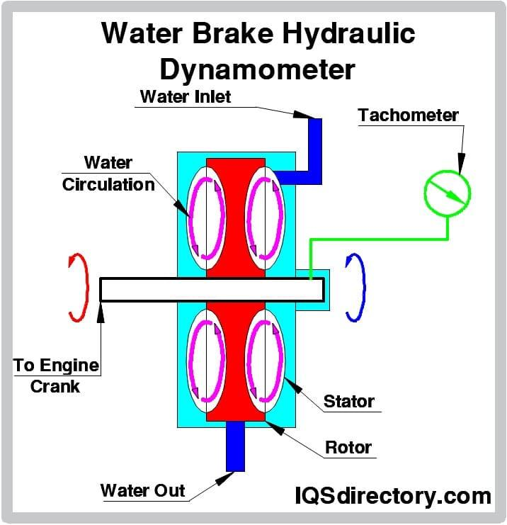
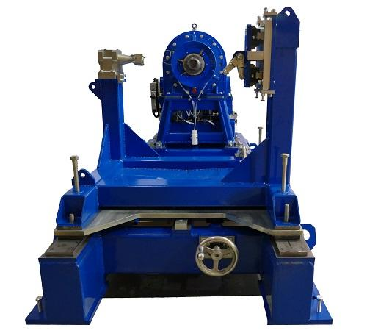
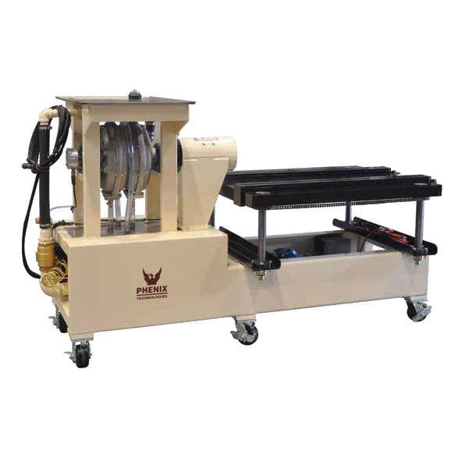
Description
Absorbs mechanical power using water resistance to measure engine output.
Features
- High power capacity
- Excellent cooling
- Reliable continuous operation
Applications
- Heavy-duty diesel engines
- Marine engines
- Large industrial engines
- Power generation testing

Measuring Units
# Source: AI Source: Provided by: [Data Path: Persons Table -> ID Column: 1, Name_En Column: Motasem Essam] -> From: [ChatGPT] on [7/17/2026]
Dynamometers commonly measure:
- Newton (N)
- Kilonewton (kN)
- Kilogram-force (kgf)
- Pound-force (lbf)
Engine dynamometers may additionally display:
- Newton-meter (N·m) (torque)
- Horsepower (hp)
- Kilowatt (kW)

Measuring Range
# Source: AI Source: Provided by: [Data Path: Persons Table -> ID Column: 1, Name_En Column: Motasem Essam] -> From: [ChatGPT] on [7/17/2026]
The measuring range depends on the dynamometer type.
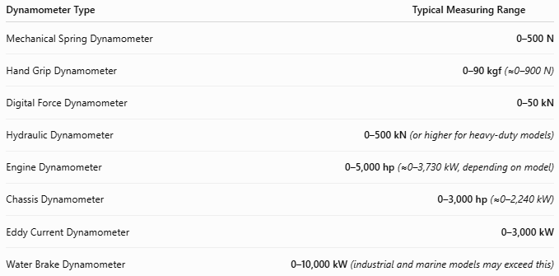
Dynamometer Type | Typical Measuring Range
Mechanical Spring Dynamometer | 0–500 N
Hand Grip Dynamometer | 0–90 kgf (≈0–900 N)
Digital Force Dynamometer | 0–50 kN
Hydraulic Dynamometer | 0–500 kN (or higher for heavy-duty models)
Engine Dynamometer | 0–5,000 hp (≈0–3,730 kW, depending on model)
Chassis Dynamometer | 0–3,000 hp (≈0–2,240 kW)
Eddy Current Dynamometer | 0–3,000 kW
Water Brake Dynamometer | 0–10,000 kW (industrial and marine models may exceed this)

Resolution
# Source: AI Source: Provided by: [Data Path: Persons Table -> ID Column: 1, Name_En Column: Motasem Essam] -> From: [ChatGPT] on [7/17/2026]
Resolution is the smallest force increment that can be displayed.
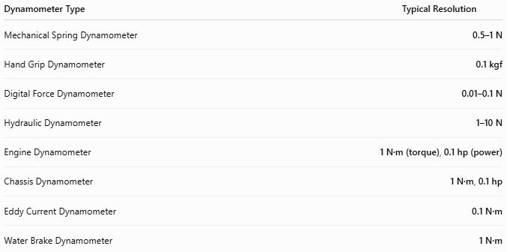
Dynamometer Type | Typical Resolution
Mechanical Spring Dynamometer | 0.5–1 N
Hand Grip Dynamometer | 0.1 kgf
Digital Force Dynamometer | 0.01–0.1 N
Hydraulic Dynamometer | 1–10 N
Engine Dynamometer | 1 N·m (torque), 0.1 hp (power)
Chassis Dynamometer | 1 N·m, 0.1 hp
Eddy Current Dynamometer | 0.1 N·m
Water Brake Dynamometer | 1 N·m

Accuracy
# Source: AI Source: Provided by: [Data Path: Persons Table -> ID Column: 1, Name_En Column: Motasem Essam] -> From: [ChatGPT] on [7/17/2026]
Accuracy indicates how closely the measured value matches the true applied force or power.
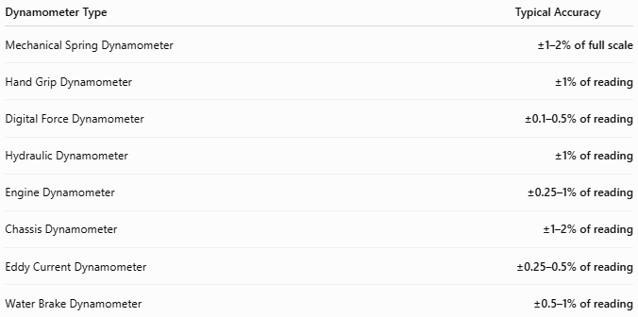
Dynamometer Type | Typical Accuracy
Mechanical Spring Dynamometer | ±1–2% of full scale
Hand Grip Dynamometer | ±1% of reading
Digital Force Dynamometer | ±0.1–0.5% of reading
Hydraulic Dynamometer | ±1% of reading
Engine Dynamometer | ±0.25–1% of reading
Chassis Dynamometer | ±1–2% of reading
Eddy Current Dynamometer | ±0.25–0.5% of reading
Water Brake Dynamometer | ±0.5–1% of reading

Notes
- Mechanical spring dynamometers are simple and economical but generally provide the lowest accuracy due to spring wear and mechanical friction.
- Digital force dynamometers use electronic load cells, offering high precision and excellent repeatability for laboratory and industrial measurements.
- Hydraulic dynamometers are ideal for measuring very large forces, though periodic calibration is required to maintain accuracy.
- Engine and chassis dynamometers calculate power by combining measured torque and rotational speed, making them essential for automotive performance testing and engine development.
- Eddy current dynamometers provide smooth, electronically controlled loading and are highly accurate for engine and motor testing.
- Water brake dynamometers are capable of absorbing very high power levels and are commonly used for marine engines, heavy-duty diesel engines, and industrial power systems.

How to Use a Dynamometer
# Source: AI Source: Provided by: [Data Path: Persons Table -> ID Column: 1, Name_En Column: Motasem Essam] -> From: [ChatGPT] on [7/17/2026]
- Turn on the instrument (if electronic).
- Zero or calibrate the device.
- Attach the object or apply the force.
- Apply the force gradually.
- Wait for the reading to stabilize.
- Record the displayed value.

Example
# Source: AI Source: Provided by: [Data Path: Persons Table -> ID Column: 1, Name_En Column: Motasem Essam] -> From: [ChatGPT] on [7/17/2026]
Displayed force:
245 N
Measured force:
245 Newtons

Applications
# Source: AI Source: Provided by: [Data Path: Persons Table -> ID Column: 1, Name_En Column: Motasem Essam] -> From: [ChatGPT] on [7/17/2026]
Dynamometers are used in:
- Automotive engineering
- Engine testing
- Industrial manufacturing
- Mechanical testing
- Material testing
- Medical rehabilitation
- Sports science
- Scientific research
- Quality control

Advantages
# Source: AI Source: Provided by: [Data Path: Persons Table -> ID Column: 1, Name_En Column: Motasem Essam] -> From: [ChatGPT] on [7/17/2026]
A dynamometer:
- Measures force accurately.
- Can measure both tension and compression (depending on model).
- Digital models provide high precision.
- Engine dynamometers measure real performance under load.
- Suitable for laboratory and industrial environments.

Limitations
# Source: AI Source: Provided by: [Data Path: Persons Table -> ID Column: 1, Name_En Column: Motasem Essam] -> From: [ChatGPT] on [7/17/2026]
A dynamometer:
- Mechanical models may lose calibration over time.
- Hydraulic systems require maintenance.
- Electronic models require electrical power.
- Engine dynamometers are large and expensive.

Sources of Error
# Source: AI Source: Provided by: [Data Path: Persons Table -> ID Column: 1, Name_En Column: Motasem Essam] -> From: [ChatGPT] on [7/17/2026]
Instrument Errors
- Calibration drift
- Sensor wear
- Hydraulic leakage
- Load-cell failure

User Errors
- Off-axis loading
- Sudden shock loading
- Exceeding rated capacity

Environmental Errors
- Temperature changes
- Vibration
- Electrical interference (digital models)

Comparison with Other Force Measuring Instruments
# Source: AI Source: Provided by: [Data Path: Persons Table -> ID Column: 1, Name_En Column: Motasem Essam] -> From: [ChatGPT] on [7/17/2026]
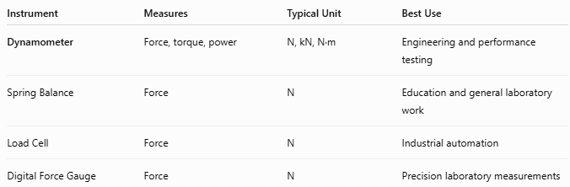
Instrument | Measures | Typical Unit | Best Use
Dynamometer | Force, torque, power | N, kN, N·m | Engineering and performance testing
Spring Balance | Force | N | Education and general laboratory work
Load Cell | Force | N | Industrial automation
Digital Force Gauge | Force | N | Precision laboratory measurements

Care and Maintenance
# Source: AI Source: Provided by: [Data Path: Persons Table -> ID Column: 1, Name_En Column: Motasem Essam] -> From: [ChatGPT] on [7/17/2026]
To maintain accuracy:
- Calibrate regularly.
- Avoid overloading.
- Store in a clean, dry environment.
- Protect electronic sensors from moisture.
- Inspect hooks and fixtures before use.

Common Mistakes
# Source: AI Source: Provided by: [Data Path: Persons Table -> ID Column: 1, Name_En Column: Motasem Essam] -> From: [ChatGPT] on [7/17/2026]
- Applying force beyond the rated capacity.
- Measuring off-center loads.
- Forgetting to zero the instrument.
- Using an uncalibrated device.
- Subjecting the sensor to impact loads.

Key Points
# Source: AI Source: Provided by: [Data Path: Persons Table -> ID Column: 1, Name_En Column: Motasem Essam] -> From: [ChatGPT] on [7/17/2026]
- A Dynamometer measures force, torque, or mechanical power.
- Common types:
  - Mechanical Spring Dynamometer
  - Hand Grip Dynamometer
  - Digital Force Dynamometer
  - Hydraulic Dynamometer
  - Engine Dynamometer
- Common units:
  - N
  - kN
  - kgf
  - lbf
  - N·m
  - hp
  - kW
- Dynamometers are essential in engineering, medicine, sports science, automotive testing, and industrial quality control.

Conclusion
# Source: AI Source: Provided by: [Data Path: Persons Table -> ID Column: 1, Name_En Column: Motasem Essam] -> From: [ChatGPT] on [7/17/2026]
A Dynamometer is a versatile force-measuring instrument capable of measuring force, torque, and mechanical power across a wide range of applications. From evaluating human grip strength to testing the performance of high-power engines, dynamometers provide accurate and reliable measurements that support engineering design, equipment maintenance, medical assessment, research, and industrial quality assurance.

